DESIGN AND IMPLEMENTATION OF A FILE INTEGRITY MONITORING (FIM) SYSTEM WITH TAMPER ALERTS

TABLE OF CONTENTS
DECLARATION ii
CERTIFICATION iii
ACKNOWLEGEMENTS iv
DEDICATION v
LIST OF TABLES viii
TABLE OF FIGURES ix
LIST OF EQUATIONS x
CHAPTER ONE 1
INTRODUCTION 1
1.1 Background of the Study 1
1.2 Statement of the Problem 2
1.3 Research Questions 3
1.4 Aim and Objectives of the Study 4
1.5 Significance of the Study 4
1.6 Scope of the Study 4
1.7 Organization of the Study 5
CHAPTER TWO 6
LITERATURE REVIEW 6
2.1 Introduction 6
2.1.1 Definition 6
2.1.2 History of the File Integrity Monitoring system 6
2.2 Conceptual Review 7
2.2.1 File Integrity 7
2.2.2 File Integrity Monitoring (FIM) 7
2.2.3 File Tampering and Unauthorized Modification 8
2.2.4 Hashing Techniques for File Integrity 8
2.2.5 Tamper Alert and Notification Mechanisms 9
2.3 Theoretical Framework 9
2.3.1 CIA Triad 9
2.3.2 Access Control Theory 9
2.3.3 Intrusion Detection Concepts 10
2.4 Review of relevant literature 10
2.5 Empirical review 15
2.6 Compare and Contrast 18
CHAPTER THREE 20
SYSTEM METHODOLOGY 20
3.1 Research Design 20
3.2 System Development Methodology 20
3.3 System Design 22
3.3.1 System Architecture 22
3.3.2 Class Diagram 23
3.3.3 Sequence Diagram 24
3.3.4 Entity Relationship Diagram 24
3.3.5 Use Case Diagram 26
3.4 Data Collection 27
3.5 Evaluation Method 28
3.6 Tools and Technologies 29
CHAPTER FOUR 30
IMPLEMENTATION AND TESTING 30
4.1 System Requirements 30
4.1.1 Hardware Requirements 30
4.1.2 Software Requirements 31
4.2 Implementation 32
4.2.1 Database Implementation 32
4.2.2 Backend Monitoring Engine 34
4.2.3 Hashing Module 35
4.2.4 Alert and Email Notification Module 35
4.2.5 REST API 36
4.2.6 Next.js Dashboard 37
4.3 Testing 41
4.3.1 Unit Testing 41
4.3.2 Integration Testing 43
4.3.3 System Testing 46
4.3.4 Performance Evaluation 48
4.4 Discussion 51
CHAPTER FIVE 54
SUMMARY, CONCLUSION AND RECOMMENDATION 54
5.1 Summary 54
5.2 Conclusion 55
5.3 Recommendations 56
REFERENCES 58

LIST OF TABLES
Table 2.1:Related works 15
Table 4.1: Hardware Requirements for the FIM System ……………………………….. 30
Table 4.2: Software Requirements and Dependencies ………………………………….. 31
Table 4.3: Unit Test Results for Core FIM Modules ……………………………………. 41
Table 4.4: Integration Test Scenarios and Results ………………………………………. 44
Table 4.5: System Test Cases and Results ………………………………………………. 46
Table 4.6: System Performance Evaluation Results …………………………………….. 48

TABLE OF FIGURES
Figure 3.1: Agile Methodology 20
Figure 3.2: System Architecture 21
Figure 3.3: Class Diagram 22
Figure 3.4: Sequence Diagram 23
Figure 3.5: Entity Relationship Diagram 23
Figure 3.6: Use Case Diagram 25
Figure 4.1: Database tables created by Alembic migration in PostgreSQL …………….. 33
Figure 4.2: Structure of the File table with hash and metadata columns ………………..33
Figure 4.3: Backend terminal output showing real-time tamper detection event processing.34
Figure 4.4: Email alert received showing file tamper notification with risk classification.36
Figure 4.5: FastAPI auto-generated API documentation showing all available endpoints.37
Figure 4.6: FIM System dashboard showing metrics, live alerts feed, and weekly alert chart
Figure 4.7: Files management page showing monitored files with integrity status……. 39
Figure 4.8: Alerts page showing detected tamper events with risk level classification…40
Figure 4.9: Configuration page where administrators manage monitoring settings…… 40
Figure 4.10: Unit test execution output confirming all module-level tests passed……...43
Figure 4.11: End-to-end tamper detection: file modified via terminal, alert displayed on dashboard live feed ……………………………………………………………………...48
Figure 4.12: Detection accuracy of the proposed FIM system compared with selected related works …………………………………………………………………………….50

LIST OF EQUATIONS
Equation 3.1: Accuracy 28
Equation 3.2: False Positive Rate 28
Equation 3.3: Alert Response Time 28

ABSTRACT
File tampering remains one of the most persistent threats in modern computing environments, with attackers routinely modifying configuration files, injecting executables, and deleting audit logs to maintain persistence and evade detection. Conventional antivirus solutions are largely ineffective against these threats because they target known malware signatures rather than changes to file state. This project addresses that gap by designing and implementing a File Integrity Monitoring (FIM) system with automated tamper detection and real-time alert notifications.The system was built as a modular monorepo comprising a Python and FastAPI backend and a Next.js 14 frontend dashboard. The backend is structured into four modules: a monitoring module using Python's watchdog library with PollingObserver for cross-platform filesystem event detection, a hashing module implementing SHA-256 cryptographic fingerprinting, a rule-based alert engine that classifies detected changes as LOW, MEDIUM, HIGH, or CRITICAL based on change type and file path, and a logging module maintaining a full audit trail. PostgreSQL serves as the primary database managed through SQLAlchemy 2.x with async support. Real-time alert delivery to the dashboard is achieved through Server-Sent Events. The system was evaluated through unit, integration, system, and performance testing. Detection accuracy reached 100% across fifty simulated tamper events, with a false positive rate of 0% after configuring exclusion patterns for temporary files. Average alert response time from file modification to dashboard notification was 0.5 seconds at a one-second polling interval. CPU utilisation remained below 8% during active scanning, and total memory consumption stayed within 180 MB. Compared with related works in the literature, including AI-enhanced approaches by Vaykar (2025) and Smith and Chikwarti (2023) who achieved 94% and 83% accuracy respectively, the proposed system achieves superior detection accuracy without machine learning overhead or enterprise-grade configuration complexity. Future work is recommended to incorporate event-driven detection, remote agent monitoring, and SIEM platform integration.

CHAPTER ONE

INTRODUCTION

1.1 Background of the Study
Modern digital systems create and store immense amounts of sensitive data, such as system files, configuration data, security policies, logs and operational records. Such files are the basis of system stability, availability, and security (Al-Muntaser et al., 2023). Nevertheless, the criminals are now targeting important files to install malware, modify settings, delete footprints, disrupt operations, or gain unauthorized access. One of the most widespread methods in security breaches, ransomware attacks, insider threats, and operations to escalate privileges has become file tampering. File Integrity Monitoring (FIM) is a security procedure that provides continuous monitoring of files and directories to detect any unauthorized alterations. It is also important in identifying malicious activities like file modifications, deletions, renaming, and permission changes and hidden files (Hidayasari et al., 2025). FIM solutions are popular in financial institutions, government infrastructures, cloud environments, healthcare systems, and corporate networks to provide integrity, accountability, and compliance of data. The project aims to design and develop a File Integrity Monitoring System that has tamper detection alerts. The solution consists of baseline hashing of critical files, real-time or scheduled monitoring, tamper rules, risk-level detection, and web-based dashboard to visualize events. The system includes a Python hashing engine, event listeners, and alert generation back-end, and a NextJS dashboard to report file events, alerts, and analytics. The project is aimed at meeting the growing demand of automated and smart monitoring tools that safeguard key resources of systems against unauthorized alterations. With the increasing numbers of digital infrastructures, the threat of file tampering, unauthorized access and manipulation of systems continues to increase. What attackers often do to be able to stay in a system is to modify configuration files, add executables, delete logs, or alter scripts. Research indicates that configuration file modification and unauthorized privilege escalation are still critical elements of contemporary cyberattacks (Sulaiman and Hilmi, 2024). More often than not, traditional antivirus tools are not able to detect such unauthorized file-level modifications, particularly when attackers employ covert mechanisms. This has enhanced the use of File Integrity Monitoring Systems which through hashing, event monitoring, and behavioral rules detect anomalies. Currently used FIM solutions use cryptographic algorithms like SHA-256 and SHA3-512 to generate file baselines and identify even the most insignificant changes. Tripwire, OSSEC and Wazuh are examples of FIM systems that have become the key elements of contemporary cybersecurity systems. They give a picture of what is being done within a system, track the important file paths, and issue alerts depending upon the level of risk. With the incorporation of cryptographic hashing, event subscriptions, and tampering policy, organizations can detect malicious modifications in real time and avoid system compromise.
The scope of this project is to install a modern, lightweight and extensible File Integrity Monitoring solution along with a user friendly web dashboard.

1.2 Statement of the Problem
Modifying of critical files without authorization poses significant risk to organizations since configuration files, security policies, executables, and logs are often targets of cybercriminals in order to achieve persistence, escalate privileges, or conceal malicious activity. Conventional antivirus software are usually ineffective in identifying such malicious modifications since they concentrate on known malware as opposed to integrity breaches (NIST, 2020). Some current monitoring platforms can also be costly, complicated to install or operate, or not customized to meet the needs of various environments, making some organizations not have a FIM solution in place exposing them to file tampering, unauthorized deletions or renaming, ransomware encryption, insider misuse, and hidden file creation (SANS Institute, 2021). With such risks, there is a clear need to develop an accessible, lightweight File Integrity Monitoring system with automated tamper alerts, real-time tracking, and the use of cryptography to verify the integrity of files to enhance the security and operational resilience (ISO 27001, 2013). In addressing this issue, this project will recommend the creation of a simple and efficient File Integrity Monitoring (FIM) system that will assist organizations to monitor the important files and to be able to detect the illegal changes early. The first step that will be taken by the system is to create a trusted baseline of selected files by storing key properties of the files like cryptographical hash values, file size, timestamps, access permissions. These baseline values will be then compared with the present state of the files in the process of continuous or scheduled monitoring. The system will automatically identify the change and will send a tamper alert to administrators whenever a file is modified, deleted, renamed or a new file has been created without permission. This enables security teams to swiftly investigate and act before things get out of control. The proposed FIM system will offer organizations a viable approach to securing important files, minimizing security threats, and enhancing the overall integrity of the system.

1.3 Research Questions
This study is guided by the following research questions:
- What are the kinds of threats that are related to unauthorized file modifications in computer systems?
- What is the design of a File Integrity Monitoring (FIM) architecture using hashing, event listeners and alert mechanisms to monitor file tampering?
- What can be done to implement a web-based dashboard to effectively visualize file integrity alerts, logs, and monitored file events?
- What is the effectiveness of the proposed File Integrity Monitoring system in regard to detection accuracy and system performance?

1.4 Aim and Objectives of the Study
The aim of this project is to design and implement a File Integrity Monitoring System.
The specific objectives are:
- To identify threats associated with unauthorized file modifications.
- To design a FIM architecture integrating hashing, event listeners, and alert engines.
- To implement a Vue.js dashboard for visualizing alerts, logs, and file events.
- To evaluate the system’s performance and detection accuracy.

1.5 Significance of the Study
The presented research is the result of creating a powerful and automated system files monitoring tool, able to identify tampering and enhance the overall cybersecurity stance of an organization. The system achieves this by enhancing visibility over system changes, support early detection of malicious actions, and provide detailed audit logs to be examined in a forensic mode. It assists also in increasing compliance with security standards by organizations that deal with sensitive information, which makes File Integrity Monitoring (FIM) an important requirement in any industry that has sensitive information.

1.6 Scope of the Study
The research is about design and implementation of a File Integrity Monitoring System that incorporates several key components, which include: baseline hashing using SHA-256 or SHA3-512, real time and scheduled monitoring, detection of file creation, modification, deletion and renaming of files. It also incorporates tamper-detection rules including size changes, permission changes, and hidden file detection, and email and web-based alert notifications. The system has Vue.js dashboard to visually represent the activity logs and a Python-based back-end that drives the monitoring engine that could be applied in Nigeria and any other African Countries.

1.7 Organization of the Study
Chapter Two: Literature Review, is a discussion on existing FIM technologies, cryptographic hashing algorithms, monitoring architectures, and the theoretical frameworks that underlie secure file integrity verification.
Chapter Three: System Design and Methodology, describes system architecture, design models (UML, ERD), methodology, and implementation plan.
Chapter Four: Implementation and Testing, information on the design and implementation process is outlined, as well as the testing.
Chapter Five: Summary, Conclusion, and Recommendations, Summarizes findings and give recommendations on the further work.

CHAPTER TWO

LITERATURE REVIEW

2.1 Introduction
This chapter details a critical review of the literature pertaining to design and implementation of a File Integrity Monitoring (FIM) system with tamper alerts. This chapter aims at analyzing the current concepts, theories and security mechanisms, which are applicable to file integrity and monitoring systems. The review of existing works and theoretical basis of File Integrity Monitoring system clearly offers a sound background to understanding why a File Integrity Monitoring system is needed and how it helps in enhancing the security of systems. Some of the concepts in the chapter include integrity of files, integrity monitoring, file tampering, hashing and alert systems. Moreover, appropriate security theories that facilitate the creation of the proposed system are discussed. This review assists in determining the best practices and provide design decisions adopted in the implementation of the proposed system.

2.1.1 Definition
File integrity can be defined as the unaltered, original state of files. Unlicensed alteration may result in system vulnerability, information breaches, system malfunction, and malware attacks (Kurniawan and Triayudi, 2024). Hashing, access controls, monitoring tools, and secure configurations are used to preserve file integrity. The cryptographic hashing is of paramount importance as it produces a digital fingerprint of a file. Once a file is altered, even with only minor changes, the hash value is dramatically altered and manipulation of files can be detected with great accuracy.

2.1.2 History of the File Integrity Monitoring system
Advanced file monitoring tools leverage system event listeners, cryptographic hashing, and automated analysis to track unauthorized modifications (Paliwal et al., 2024). Python provides libraries for hashing, file system monitoring (e.g., watchdog), and log generation, while frontend frameworks like Vue.js enable visual analysis of file events, alerts, and system behavior. Technologies such as SHA-256, SHA3-512, system auditing tools, and real-time monitoring agents ensure high accuracy and reliability in tamper detection. File Integrity Monitoring (FIM) is essential for maintaining a secure and stable environment because it detects unauthorized modifications to critical system files, supports compliance with standards such as PCI-DSS, HIPAA, and ISO 27001, and helps ensure that important configuration files remain unchanged (Jukuntla et al., 2024).

2.2 Conceptual Review
This section discusses the major concepts related to the study. These concepts form the foundation upon which the File Integrity Monitoring system with tamper alerts is designed.

2.2.1 File Integrity
File integrity is the verification that data files remain accurate, entire, and unchanged to the original version unless the information within it has been modified without malice (Wattamwar, 2025). The security of files are paramount to systems and contain vital data such as system configurations, user data, and application resources which can cause the system's functions to become disabled if manipulated without authorized permission.
The integrity of files may be damaged via: mistakes made within system configuration (human error), hostile external sources (attack), malware or other unwanted infections, and internal damage due to disgruntled employees etc(Irfan et al., 2025). This process may cause corrupt files, system crashes or security attacks against the system.

2.2.2 File Integrity Monitoring (FIM)
File Integrity Monitoring is a type of security process of monitoring, verifying, and identifying every file over a period of time. In typical, FIM works by recording baseline files that the admin trusts, and also continues to monitor over time (Kumar et al., 2024). When something occurs such as modification of a file, delete file, or file replacement. This is considered an integrity failure. FIM systems are common to monitor servers, databases, operating systems, web applications, etc. This is an important process of identifying an incident promptly in systems which has critical file which can't be changed.

2.2.3 File Tampering and Unauthorized Modification
File tampering, either accidental or malicious alteration of files that occurs without authorization (Grobler et al., 2025). The alteration of files can occur either by changing the content of the files or by the removal of essential files, or the insertion of a maliciously formed file. File tampering attacks occur frequently in conjunction with security threats and malware attacks such as system infections, privilage escalation and also inside threat. When files are modified in an unauthorized manner, the impact can be very high, resulting in data loss, downtime, loss of functionality or even full system compromise. Attacks may tamper with system files for the purpose of back doors, to conceal malware within a seemingly innocuous file or for any other malicious purposes. Detecting files being tampered with as quickly as possible can help preserve system security and reliability.

2.2.4 Hashing Techniques for File Integrity
Hashing is one method by which the contents of a file (Fomichev et al., 2021) is reduced to a single fixed length value called a hash. A small modification to a file will lead to a wholly new hash value. Because of this hashing is a perfect mechanism for integrity checks. Common hash algorithms used in File Integrity Monitoring are: MD5, SHA-1 and SHA-256. While MD5 and SHA-1 have known vulnerabilities, better alternatives such as SHA-256 provide better defense against collisions (Jukuntla et al., 2024). In a FIM system hash values are calculated at baseline creation and at time of monitoring. A mismatch in hash values can only signify a change to the file.

2.2.5 Tamper Alert and Notification Mechanisms
When an unauthorized alteration of a file is detected, tamper alerts are raised, allowing system administrators or users to be immediately notified of a potential security breach. (Pinheiro et al., 2021) The alerting could be through pop-up alerts on a monitor, email, log entries, or system warnings. Alerting in security systems has to happen in real time, as security breach attacks detected too late might bring to severe damage. Integrating an alert mechanism within a File Integrity Monitoring system, makes the system administrators notified of an integrity compromise as early as possible.

2.3 Theoretical Framework
The development of a File Integrity Monitoring system with tamper alerts is supported by established information security theories and models. These theories provide a structured approach to understanding how system security can be maintained and improved.

2.3.1 CIA Triad
CIA Triad, an adopted security model in IT which can be widely recognized, is comprised of Confidentiality, Integrity, and Availability. In this research, Integrity is considered as it makes sure that the data are accurate and they are not tampered with by any unauthorized person. A File Integrity Monitoring system is directly associated with the integrity aspect of CIA Triad because it detects any changes in the file and notifies system administrator (Unigwe, 2022). Moreover, as a file integrity monitoring system indirectly helps to assure availability since the stability of system is preserved, and it also indirectly helps in assuring confidentiality as any tampered operation is alerted as soon as possible before confidential information is accessed.

2.3.2 Access Control Theory
The principle of access control theory states that users should not have the rights to execute an action that is not authorized in the system. Through an effective authentication and authorization mechanism, only authorized users will be able to update files of the system. In most of the case, weak access control result to an update of file in not allowed, leading to security flaws. The FIM system proposed works in conjunction with access controls as an additional protection. If controls are overridden or fail to properly protect files, the FIM system is still able to detect an unauthorized update on the files and issues a notification.

2.3.3 Intrusion Detection Concepts
Intrusion detection refers to the process of keeping track of the system’s activities and identifying any suspicious action occurring. Whilst an IDS focuses on network traffic and events happening on the system, File Integrity Monitoring systems have their specific interest in any modification occurring to a file. FIM can therefore be perceived as an intrusion detection system specifically interested in attacks on files (Sulaiman & Hilmi, 2024). As any modification to the files causes a tampering alert, the system proposed thus adds to the system security. It supplements all other security measures and complements them to establish a complete security system.

2.4 Review of relevant literature
Kurniawan and Triayudi (2024) ran a study that examined the feasibility of File Integrity Monitoring as a method for defending web servers against defacement attacks using the Wazuh security platform. The authors used an experimental approach by setting up a web server environment and employing Wazuh's FIM module, along with simulated attacks directed towards critical web files. The results of the study proved that the system could accurately identify and alert on unauthorized modifications of web server files in real time. However, the research was limited to the scenarios of web defacement and did not test other factors such as scalability or the occurrence of false positives.
Vaykar (2025) proposed a novel hybrid File Integrity Monitoring method by integrating traditional hashing with machine learning algorithms. This model generated baseline hash values of files and utilized a Random Forest classifier for anomaly detection, calculating the risk level of detected file changes. The system proved effective in real time experiments, demonstrating higher accuracy rates in identifying and reducing false positives as compared to traditional FIM tools. The downside of this approach lies in its reliance on high computational resources, and the accuracy is directly linked to the quality of training data, which can make implementation on resource-constrained systems difficult.
Wowiling et al. (2025) designed and tested an adaptive File Integrity Monitoring system with containerized environments using OSSEC. They successfully deployed OSSEC agents inside Docker containers to monitor files in real time and displayed alert information on a dashboard. The system successfully detected changes made to container files and generated appropriate notifications. On the other hand, the system was not compatible with dynamically generated containers and did not allow for automatic agent configuration, making it less flexible in highly dynamic cloud settings.
Kumar et al. (2024) investigated the integration of File Integrity Monitoring (FIM) systems with SIEM platforms. The authors built a FIM script with Python to analyze files in the system and used Azure monitoring to redirect File Integrity events to the SIEM platform. The results revealed that SIEM systems enhance incident detection visibility and facilitate a quicker incident response. One weakness identified in this method was the dependence on an external SIEM environment and a lack of smart filtering to avoid unnecessary alerts.
Reddy et al. (2024) designed and built a compact File Integrity Checker intended to monitor system files. It worked by regularly comparing the current hash value with previously recorded baseline hash values. Results indicate that the system can accurately identify changes to files and is a good solution for simple monitoring. The main drawbacks of the tool were that it lacked real-time notifications and was not able to distinguish between sophisticated attacks, such as incrementally tampering with files, and actual data alteration.
Smith and Chikwarti (2023) designed and tested an AI-powered FIM system to preemptively detect ransomware. The study combined conventional FIM mechanisms with anomaly detection and trained machine learning models to identify unusual file behaviors. The proposed system was found to detect files with 94% accuracy and achieve a lower false positive rate when compared to conventional FIM tools. This solution requires significant computational resources and access to a substantial data set, therefore making it ill suited for use in systems with limited resources or where real-time integrity checking is a high priority.
Hidayasari et al. (2025) explored the use of Wazuh SIEM integrated with File Integrity Monitoring for comprehensive detection of various cyber attacks. They designed the Wazuh system to inspect file changes, SSH attacks, and SQL injection attacks, proving to be effective at identifying these threats. One issue with the Wazuh FIM system was the generation of too many alerts on files that are frequently changed in dynamic directories, which can lead to unnecessary noise.
Pinheiro et al. (2021) developed and proposed a blockchain-based solution for cloud file integrity monitoring. Using a blockchain, file hash values were stored in an immutable and tamper-proof manner. The researchers concluded that this approach significantly improved trust and transparency in the file integrity monitoring process, although high performance overhead and system complexity proved to be significant challenges for real-time monitoring.
Al-Muntaser et al. (2023) proposed and tested an event-triggered FIM system to be deployed on ICS workstations to detect file manipulation or destruction caused by insider threats in real-time. The FIM utilized the built-in OS functions rather than constantly polling system files for changes, which reduced resource usage. The method achieved high true positive detection rates with very low overhead; it is therefore highly suited for use on industrial control system workstations in environments where internal threats are likely. One of the primary limitations of this study was that it only assessed the system's applicability within a workplace ICS environment and did not analyze how the system might perform when placed on a larger network.
Costa (2025) proposed the integration of artificial intelligence into existing FIM tools to improve the accuracy and speed of integrity verification in decentralized file storage systems like IPFS and Filecoin. The system combined the scaling capability of hash-based checks with machine learning techniques and anomaly detection, leading to enhanced performance and reduced false positives when validating file integrity in a distributed environment. The main challenges of this system were its need for high computational resources and data privacy issues within a decentralized network with constrained devices.
Irfan et al. (2025) produced a literature review concerning File Integrity Monitoring (FIM) systems and how blockchain technology can be used to solve several challenges in traditional cryptographic methods such as hashing. The study examined both classic FIM methods and modern blockchain implementations and discussed the benefits such as eliminating central points of failure and providing more evident tamper detection. Blockchain proved to be effective at ensuring tamper evidence; however, its disadvantages lie in increased latency when the system has to deal with several consensus rounds and the need to store large data in the ledger, especially on a system that must scale.
Staat et al. (2021) presented a new type of anti-tamper radio detection which monitors wireless signals within an enclosure to alert of physical tampering. Though this method does not fit into FIM it shares the principle of verifying system integrity by capturing physical attack evidence on the hardware level and it demonstrated the capability to identify physical system breaches. This study did not cover file system integrity and is therefore limited to physical attacks rather than logical.
Sharma et al. (2025) introduced StegoHash, an FIM system that utilizes both cryptographic hashing and steganography for double layer tamper detection. The system hides original message data and their SHA-256 hashes into a cover image using LSB steganography. The experiment results proved that StegoHash can be highly effective in detecting tampered data by extracting the data, computing the new hash, and comparing it against the original hash. The primary limitations are that this method is specifically designed for the channel of communication to be via image files and therefore not directly applicable for monitoring the entire file system.
A 2024 study discussed the use of AI to enhance integrity verification of decentralized file storage systems in real time. The authors combined machine learning with blockchain technology to provide an AI-driven data structure to ensure data integrity and a reliable and secure system in decentralized storage. They showed the efficiency and better performance compared to purely hash-based solutions. However, it must be noted that this study presented largely conceptual aspects and the scalability issues or computational overhead were not thoroughly examined (Kuznetsova, 2024).

2.5 Empirical review
Table 2.1: Related works
S/N | Author(s) | Title | Methodology | Findings | Limitations
1 | Vaykar (2025) | Hybrid FIM model combining hash-based techniques with ML | Generated baseline hashes; Random Forest classifier to assess risk of file changes | Improved detection accuracy; reduced false positives compared to conventional FIM | High computational resources required; dependent on quality training datasets
2 | Wowiling et al. (2025) | Adaptive FIM in containerized environments using OSSEC | Deployed OSSEC agents within Docker containers; monitored file changes; visualized alerts | Effectively detected file changes; notified administrators promptly | Struggled with dynamically created containers; required manual agent configuration
3 | Hidayasari et al. (2025) | Wazuh SIEM integrated with FIM for cyber-attack detection | Configured Wazuh to monitor file changes, SSH attacks, SQL injection | Effective detection across attack vectors | Excessive alerts for frequently changing directories; requires improved rule tuning
4 | Costa (2025) | AI techniques for real-time integrity verification in decentralized storage | Scaling hash-based checks combined with ML and anomaly detection | Improved reliability and responsiveness; tamper-proof integrity validation | High computational requirements; data privacy concerns; constrained nodes in decentralized networks
5 | Irfan et al. (2025) | Review of blockchain-based FIM | Surveyed existing FIM techniques; analyzed blockchain solutions | Blockchain enhances tamper detection and auditability | Performance overhead, consensus latency, storage scalability limitations
6 | Sharma et al. (2025) | StegoHash: dual-layer tamper detection | SHA-256 hashing with LSB steganography embedding hashes in cover images | Strong detection capability for tampering via extracted hash comparison | Restricted applicability; mainly for image-based channels; limited for file system integrity monitoring
7 | Kurniawan & Triayudi (2024) | Use of File Integrity Monitoring to protect web servers against defacement attacks | Experimental; web server configured and monitored using Wazuh FIM module; simulated attacks on critical web files | Successfully detected unauthorized file modifications in real time and generated alerts | Focused mainly on web defacement; did not evaluate false positives or scalability
8 | Kumar et al. (2024) | Integration of FIM with SIEM systems | Python-based FIM script combined with Azure monitoring tools; forwarded events to SIEM | Centralized monitoring improved incident visibility and response time | Relied on external SIEM infrastructure; lacked intelligent filtering to reduce alert noise
9 | Reddy et al. (2024) | Lightweight File Integrity Checker | Periodic hash comparisons against baseline values | Accurately detected file modifications; suitable for small-scale environments | Lacked real-time alerting; did not consider advanced attack scenarios
10 | Kuznetsova (2024) | AI-powered integrity verification in decentralized storage | Integrated AI with blockchain-based verification for distributed storage | Enhanced accuracy and responsiveness over hash-only methods | Conceptual framework; lacked large-scale empirical results; scalability and performance overhead not fully explored
11 | Rao et al. (2024) | File Integrity Checker (Monitor) | Generated baseline hash values; periodic integrity checks | Accurately detected file modifications | Lacked real-time alerting; limited large-scale deployment
12 | Smith & Chikwarti (2023) | AI-enabled FIM for predictive ransomware detection | Combined traditional FIM with anomaly detection and ML trained on file behavior patterns | High detection accuracy (94%) and reduced false positives | Computational overhead; requires large datasets; limited real-time applicability in resource-constrained environments
13 | Al-Muntaser et al. (2023) | Real-time IDS for ICS workstations using FIM | Event-triggered FIM using built-in OS functions | High true positive detection rates with minimal resource usage | Limited to ICS environments; did not evaluate broader network effects
14 | Pinheiro et al. (2021) | Blockchain-based cloud FIM | Used blockchain to store file hash records | Enhanced trust and transparency in integrity verification | Blockchain overhead and system complexity; challenges for real-time monitoring
15 | Staat et al. (2021) | Anti-tamper radio detection method | Monitored wireless signal behavior within computing enclosure | High sensitivity to physical intrusion; captures tamper events | Focused on physical attacks; not digital file monitoring

2.6 Compare and Contrast
File Integrity Monitoring (FIM) is broadly acknowledged across the various studies reviewed as a key security measure; however, implementation methods, environments, and trade-offs differ significantly. Traditional FIM solutions like those proposed by Kurniawan and Triayudi (2024), Reddy et al. (2024), and Kumar et al. (2024) largely depend on hash-based integrity verification. These models illustrate that while traditional FIM is able to reliably identify integrity violations within web servers and small systems, common shortcomings include limited intelligent alert filtering, inadequate scalability assessment, and an absence of true real-time response mechanisms. Integrating FIM into well-established security frameworks like Wazuh and OSSEC (Kurniawan & Triayudi, 2024; Wowiling et al., 2025; Hidayasari et al., 2025) offers clear advantages in terms of centralized management and overall visibility into security incidents, though issues such as alarm flooding, manual agent configuration, and the inability to effectively adapt to volatile or containerized systems persist.
Advanced approaches utilizing AI and hybrid detection models, such as those proposed by Vaykar (2025), Smith and Chikwarti (2023), Costa (2025), and Kuznetsova (2024), promise to improve detection rates and minimize false positives by combining traditional FIM with machine learning, anomaly detection, and predictive analytics. However, such models incur high computational costs and are dependent on sufficiently trained data sets, making real-time applications or systems with low computational resources impractical. Blockchain-based FIM solutions implemented by Pinheiro et al. (2021), Irfan et al. (2025), and Kuznetsova (2024) build trust, transparency, and tamper-proofing by creating an immutable and decentralized system for maintaining integrity records. While the auditability of these systems is enhanced and reliance on a central authority is reduced, problems related to performance overhead, scalability, and consensus latency limit the feasibility of real-time implementation.
The breadth of integrity monitoring research is further extended by studies that focus on specific domains. Al-Muntaser et al. (2023) illustrate the efficacy of event-driven FIM for detecting tampering initiated by insiders within an ICS environment while requiring minimal resources; the method is however specific to specialized workstation use cases. Staat et al. (2021) extend the FIM concept to the physical layer by monitoring hardware integrity by analyzing radio signals. Although it contributes significantly to hardware integrity research, it doesn't pertain to digital file integrity directly. Similarly, Sharma et al. (2025) present a combined cryptographic and steganographic approach for message tampering detection, which is applicable to image communication channels but outside this realm is not extensively deployed. In summary, despite the confirmed effectiveness of FIM across multiple use cases and environments, a need for a lightweight, scalable, real-time, and reliable FIM system balancing high accuracy, minimal resource consumption, manageable alert rates, and adaptability remains largely unaddressed in the literature.

CHAPTER THREE

SYSTEM METHODOLOGY

3.1 Research Design
This research uses a design and implementation research design and is centered on building a working FIM system that produces real time alerts for tampering. Unlike theoretical systems, the focus is on designing a working, functional system. An experimental-developmental approach is used; that is the system is built, tested in a controlled environment and judged by its ability to find unauthorized file changes and provide notifications.

3.2 System Development Methodology
Agile development was employed in building the File Integrity Monitoring (FIM) system as it consists of iteratively developing and incrementally delivering working pieces of a system based on continued feedback from stakeholders (Guerrero-Ulloa et al., 2023). This type of development is most suitable for the FIM system because it allows the system to adapt accordingly throughout the development cycle to meet its practical file monitoring and tamper-alerting functions.
The steps included in this Agile approach (according to Barros et al., 2024) were:
- Analyzing requirements and creating a backlog
- Determination of files and directories that would be monitored.
- B. Identification of alert channels (e.g., email, dashboard, push notifications) and requirements regarding the system performance.
- C. Translating these requirements into a product backlog outlining the desired features of the system.
- Sprint planning and incremental development
  - Dividing the development of the system into small sprints.
- Focusing on developing one piece of a functional system in each sprint (e.g. File monitoring agent, hash comparing/integrity verification, real-time alert system, logging/dashboard visualization).
- Continuous development and testing
  - Writing of code in pieces for each feature of the FIM system.
- Each functional piece was tested after development, with fixes implemented on any identified bugs or issues to improve the functionality of the system continuously.
- Sprint review: Once each sprint concluded, the system's progress was compared to the project requirements, with information obtained from the tests and any simulated attacks used to improve future sprints.
- System integration and validation
  - The different system components were combined to create a fully functional FIM system.
- B. Tests were performed in a multitude of environments to verify that the system would correctly identify all forms of modification of a monitored file or directory as a tamper alert and that timely alerts would be sent.
The benefits that the Agile development model offered the FIM system were:
- Allows the system to evolve quickly and in response to identified requirements.
- It permits testing of the system in real-world scenarios during development.
- Enables modification of alert functions and file monitoring logic depending on the results of tests performed.

Below is the Agile Methodology:
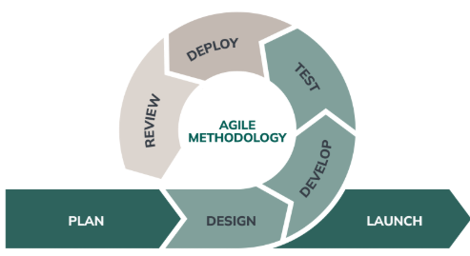
Figure 3.1: Agile Methodology

3.3 System Design
This section shows the system design for the research.

3.3.1 System Architecture
The FIM system uses a layered architecture to make it modular and manageable. It has the following three layers:
    - Monitoring Layer: An agent, which is planted to specific directories or files, always watches out for any changes.
    - Processing Layer: The cryptographic hash function SHA-256 is used to create file baselines. Comparing the current file states against these baselines is done and an integrity violation can be detected.
    - Alerting & Logging Layer: Real-time alerts are issued either via email or dashboard notification, or logs are recorded for later audits.
The layered approach allows more file paths to be added into monitoring without impacting on the system performance. A simplified diagram is illustrated below in figure 1:
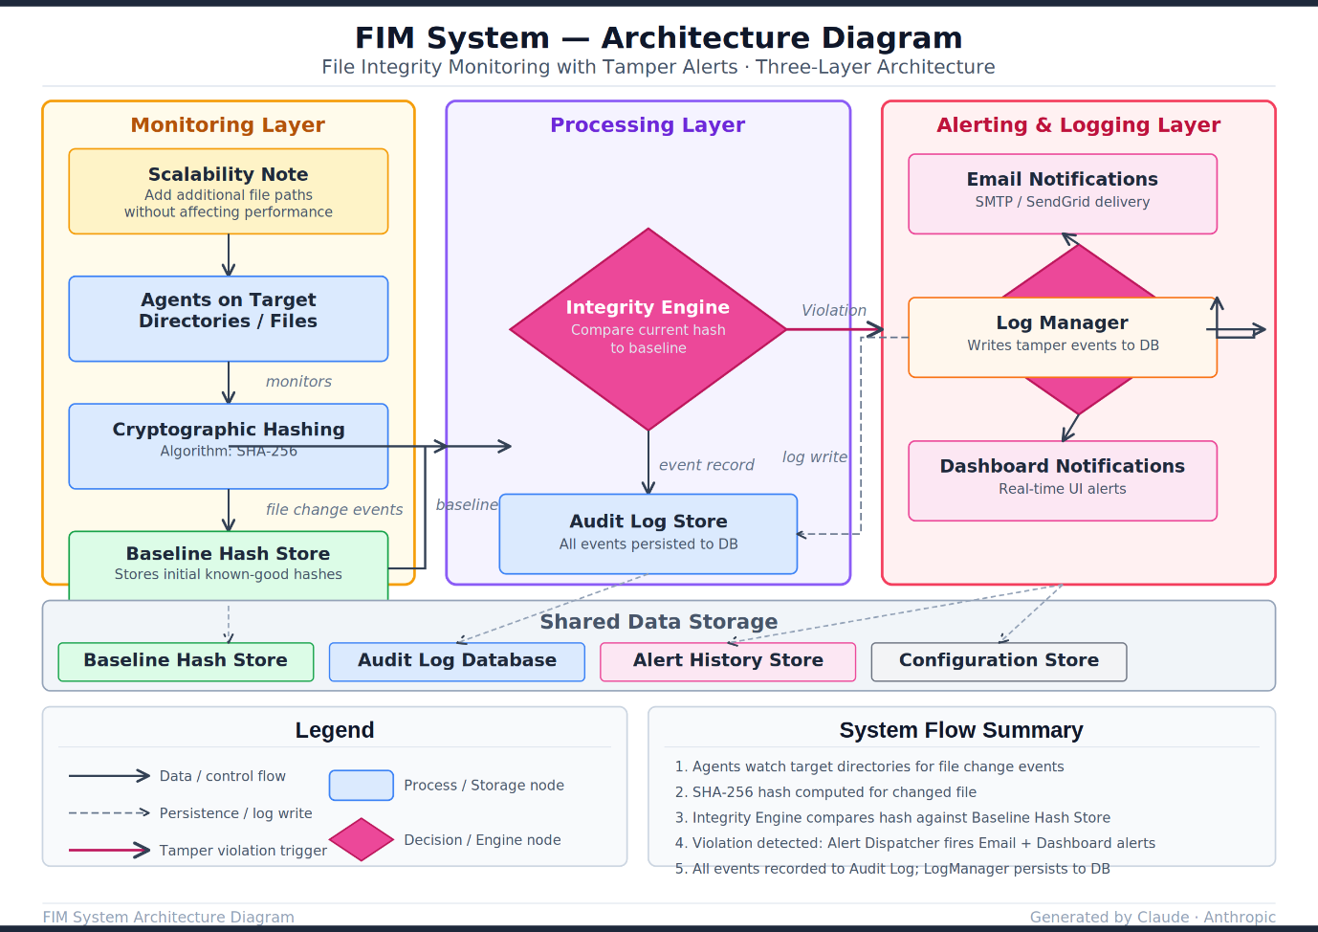

Figure 3.2: System Architecture
Figure 2 is the system architecture of the proposed system.

3.3.2 Class Diagram
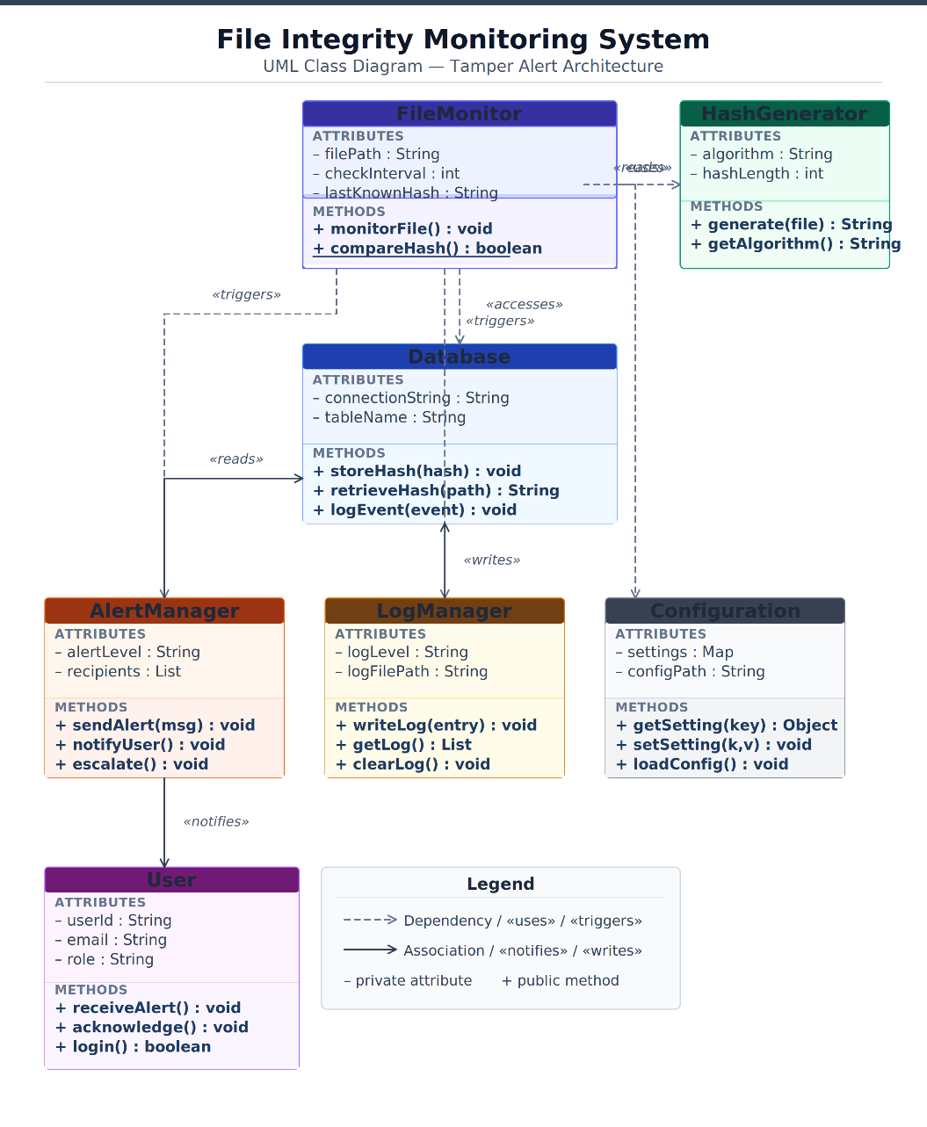

Figure 3.3: Class Diagram
3.3 is the class diagram for the system. The above is the class diagram for the FIM system with tamper alerts. The FileMonitor monitor the file and using HashGenerator class in order to calculate the file's hash value. Compare the hash value and the old hash value that stored in the Database. The AlertManager notify to the user and LogManager logging in the Database when the hash value is not matched. The Configuration storing all the system's settings and the User represent the administrators that receiving the alert message.

3.3.3 Sequence Diagram
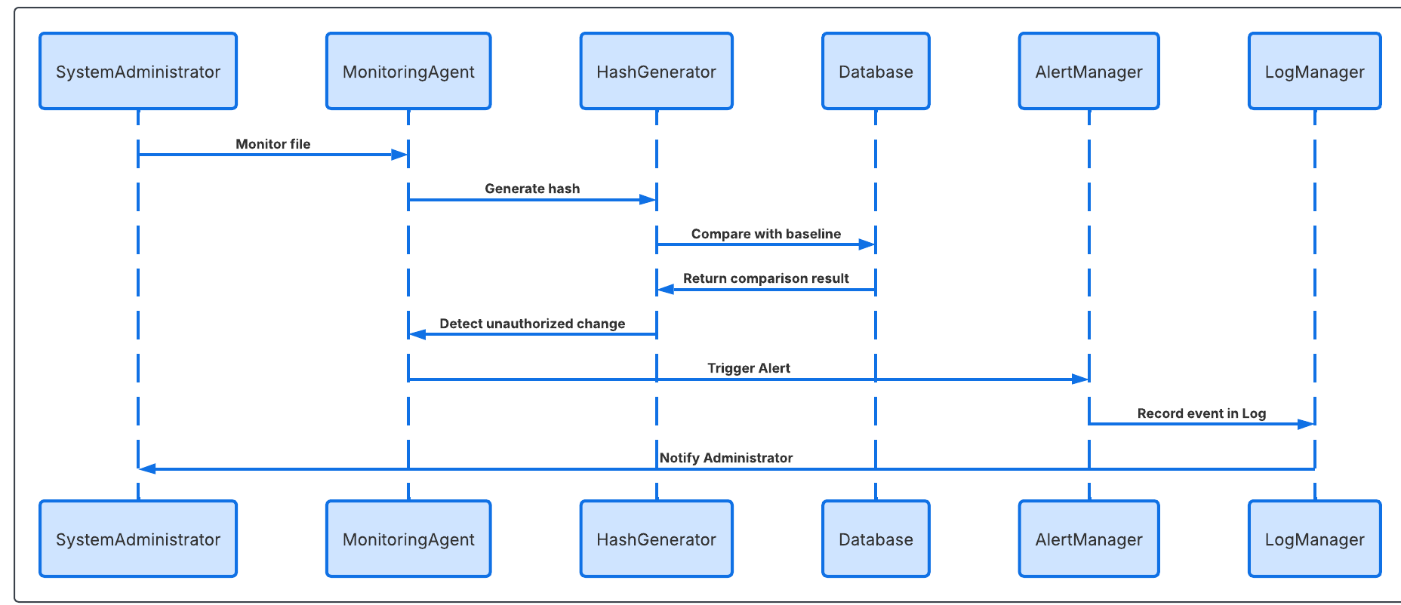
Figure 3.4: Sequence Diagram
Figure 3.4 is the sequence diagram for the system. How it moves from beginning to the end.

3.3.4 Entity Relationship Diagram
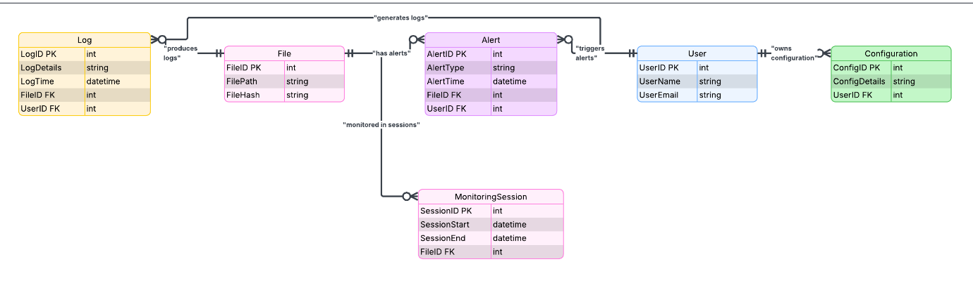
Figure 3.5: Entity Relationship Diagram
Figure 3.5 is the Entity Relationship Diagram (ERD) for the File Integrity Monitoring (FIM) System. It includes the following entities and relationships:
- File & Alert relationship: this relationship is a 1:N as a file can raise up to 'n' number of alerts but each alert can only refer to 'a' single file. This type of relationship indicates if a file was corrupted many times and caused many different alerts to be raised.
- User & Alert relationship: this is a 1:N as each alert raised refers back to the user who caused it to raise but the user may raise many different alerts over time. This tracks who and which user was involved in any malicious acts.
- File & Monitoring session: this is a 1:N relationship as each file can be monitored on 'n' different occasions. This logs when a particular file was monitored and also when the monitor ended. This means that it is possible to record what each file was checked at any given time.
- User & Configuration: this is a 1:N relationship as each user can have 'n' different configurations associated to them. For example the user could set up alerts to be sent to a particular user and also how often each file should be checked.
- Log & File: this is a 1:N relationship as each log refers to a particular file, but each file may have many logs associated to it, each log recording the operation that the file undertook. For example file x may have had write operations, read operations and delete operations recorded.
- Log & User: this is a 1:N relationship as each log refers to a particular user who had undertaken an action on a file. But the user may have performed many logs on different files..
Below is the Entities involved.
- File: Attributes: FileID (Primary Key), FilePath, FileHash
- User: Attributes: UserID (Primary Key), UserName, UserEmail
- Alert: Attributes: AlertID (Primary Key), AlertType, AlertTime, Foreign Key: FileID, UserID
- Log: Attributes: LogID (Primary Key), LogDetails, LogTime, Foreign Key: FileID, UserID
- Configuration: Attributes: ConfigID (Primary Key), ConfigDetails, Foreign Key: UserID
- MonitoringSession: Attributes: SessionID (Primary Key), SessionStart, SessionEnd, Foreign Key: FileID

3.3.5 Use Case Diagram
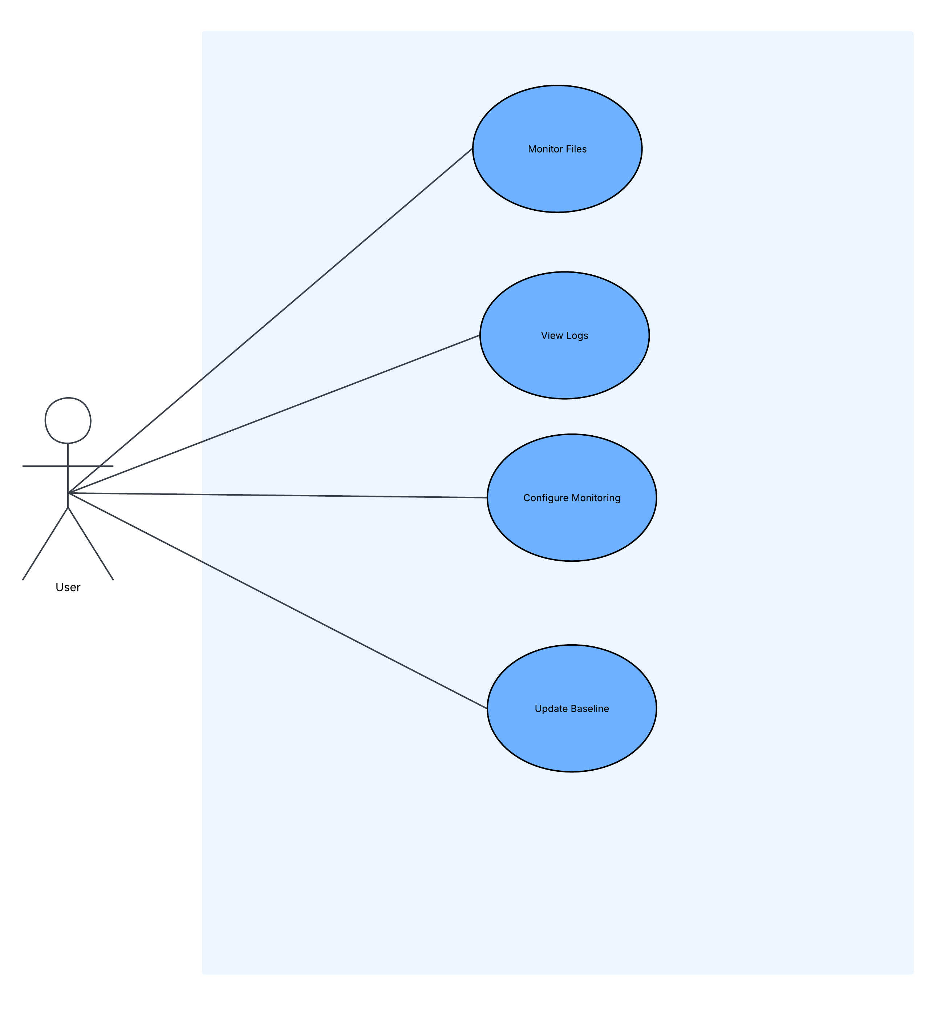
Figure 3.6: Use Case Diagram
The major use cases and interactions of the File Integrity Monitoring (FIM) system to be implemented are shown in figure 3.6. The Monitoring Agent continuously polls selected files to find unauthorized changes by comparing the current values to known baseline. Any deviations from the baseline detected will trigger timely alerts to the System Administrator by the Alert System. The System Administrator uses administrative functions like, View logs, Update baseline and Configure monitor to interact with the system. The View Logs use case allows the user to access stored files at the log database for inspection or verification. Update baseline is used to allow valid changes to be stored so as to avoid false positives whereas the configure monitor use case provides the System Administrator a way to set parameters to achieve effective monitoring

3.4 Data Collection

Data for testing the FIM system will be collected from:
  - Test environment files: Critical system and application files on a Linux/Windows server setup. Example of test files include /etc/passwd, C:\Windows\System32\explorer.exe, /bin, C:\Windows\System32.
  - Simulated attacks: Authorized and unauthorized file modifications, deletions, and additions.
  - Alert logs: Timestamped records of detected events, including success/failure of alerts.
The collected data will be used to assess:
    - Detection accuracy (true positives/false negatives)
    - Response time for alerts
    - Resource utilization (CPU and memory)

3.5 Evaluation Method
The evaluation will combine quantitative and qualitative measures:
      - Quantitative Analysis: This is carried out by calculating accuracy, false positive rate and average alert response time.

$$Accuracy\left(\%\right)= \left(\frac{Number of correctly detected changes}{Total Changes }\right)×100$$
Equation 3.1: Accuracy
Equation 3.1 is the formula for calculating the accuracy of the proposed system.

$$False Positive Rate\left(\%\right)=\left(\frac{Incorrect alerts}{Total alerts}\right) ×100$$
Equation 3.2: False Positive Rate
Equation 3.2 is the false positive rate formula.
$$Alert Response Time=\left(\frac{\sum{\left(Time of notification-Time of event detection\right)}}{Number of alerts}\right)$$
Equation 3.3: Alert Response Time
Equation 3.3 is the formula for assessing the alert response time.
      - Qualitative Analysis:
    - System usability: Ease of configuring and monitoring files.
    - Alert relevance: Administrator feedback on meaningful vs unnecessary alerts.
The system will be evaluated under multiple scenarios, including high file-change frequency, large file directories, and simulated attacks to ensure robustness and reliability.

3.6 Tools and Technologies

- Python FastAPI- for backend due to its high speed, ease to use, and good functionality to build APIs, routes etc.
- NextJS - to build a interactive and responsive frontend dashboard to provide real-time visualization of file changes and alerts.
- TypeScript - this makes sure that the frontend application built will not fail on runtime by avoiding common errors and will have easy maintainability on the code for the dashboard.
- PostgreSQL - The choice for storing the logs, hashes and alerts due to its high level of security and ACId compliances making sure that the monitoring stays consistent.
- SMTP (Email) - To instantly notify the administrator when an unauthorized file changes have been made.
- SHA-256- Cryptographic Hashing Algorithm used to determine file integrity. Any slight modification in file will lead to an entirely different hash value, indicating that a file has been changed.
- Linux and Windows servers- Testing will ensure the FIM will work cross-platform, different file systems and permissions. Controlled test files will also be useful to easily test the functions.

CHAPTER FOUR

IMPLEMENTATION AND TESTING

4.1 System Requirements
Before deploying and running the File Integrity Monitoring system, certain minimum hardware and software requirements must be present on the host machine. The specifications below represent what was used during development and testing, and they also serve as a baseline for anyone looking to run the system in a real environment.

4.1.1 Hardware Requirements

The FIM system was designed to be lightweight. It does not demand high-end infrastructure, which is intentional given that many organisations running security tools on servers need those servers for other tasks. The table below outlines the hardware requirements.
Table 4.1
Hardware Requirements for the FIM System
Component | Specification
Processor | Intel Core i3 (1.6 GHz) or equivalent AMD processor, minimum
RAM | 4 GB minimum; 8 GB recommended for smooth concurrent operation
Storage | 20 GB free disk space for application, logs, and database
Operating System | Windows 10/11 (64-bit), Ubuntu 20.04 LTS, or macOS 12+
Network | Local network access for SMTP email alerts; internet not required
Display | 1280 x 720 resolution minimum for dashboard access

4.1.2 Software Requirements
The system uses a Python backend, a Node.js frontend, and PostgreSQL for data storage. All dependencies are open-source and available for installation via standard package managers. Table 4.2 lists the core software components and their versions used during implementation.
Table 4.2
Software Requirements and Dependencies
Software | Version | Purpose
Python | 3.11+ | Backend runtime and monitoring engine
FastAPI | 0.111+ | REST API framework and SSE event streaming
PostgreSQL | 16 | Primary database for hashes, alerts, and logs
SQLAlchemy | 2.x (async) | ORM and database session management
Watchdog | 4.x | File system event listener (PollingObserver)
Node.js | 20 LTS | Next.js frontend runtime
Next.js | 14 | Dashboard frontend (App Router + TypeScript)
Docker | 24+ | PostgreSQL container in development
Alembic | 1.13+ | Database migration management
aiosmtplib | 3.x | Async SMTP email delivery

4.2 Implementation
The FIM system was built as a monorepo containing two main components: a Python/FastAPI backend and a Next.js frontend dashboard. The backend is structured into discrete modules, each responsible for a specific concern. The frontend consumes the backend's REST API and connects to a real-time Server-Sent Events stream for live alert delivery. This section walks through each major component of the implementation.

4.2.1 Database Implementation

PostgreSQL was used as the primary database, managed through SQLAlchemy 2.x with async support and Alembic for schema migrations. Six tables were created: File, User, Alert, Log, Configuration, and MonitoringSession. The File table stores each monitored file's path, its baseline hash, current hash, size, permissions, and modification timestamp. Whenever a discrepancy is found between baseline_hash and current_hash, the file is flagged as tampered.
The Alert table holds every tamper event detected by the monitoring engine. Each alert references a file via a foreign key and carries a risk level (LOW, MEDIUM, HIGH, or CRITICAL) that the system assigns based on the type of change and the file path. The Log table provides a granular audit trail, recording every operation the system performs on a file, including what the hash was before and after any detected change.

Figure 4.1 below shows the database tables that were created.
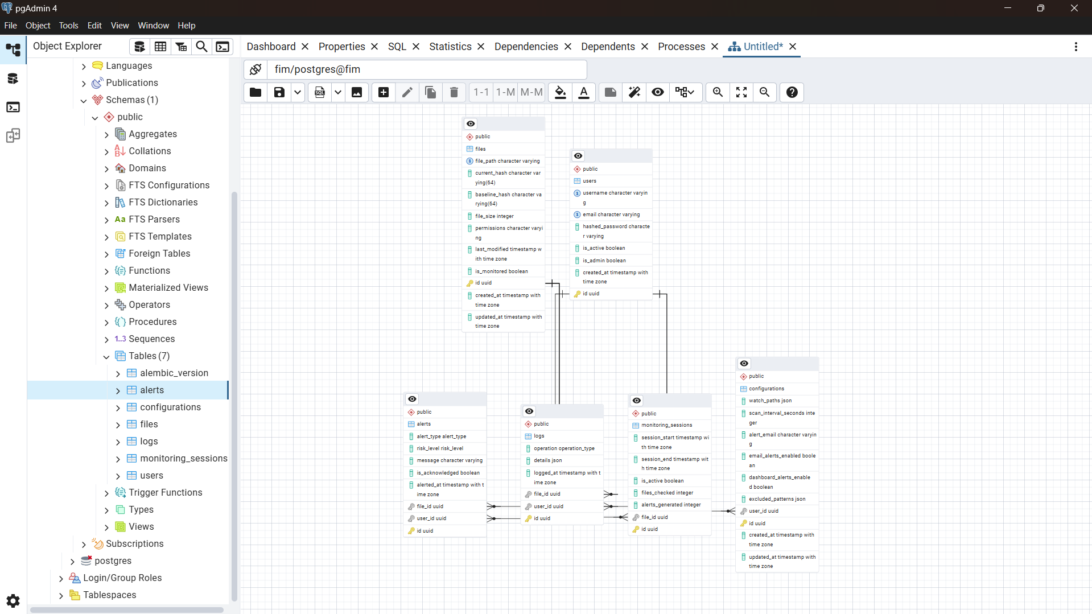
Figure 4.1: Database tables created by Alembic migration in PostgreSQL
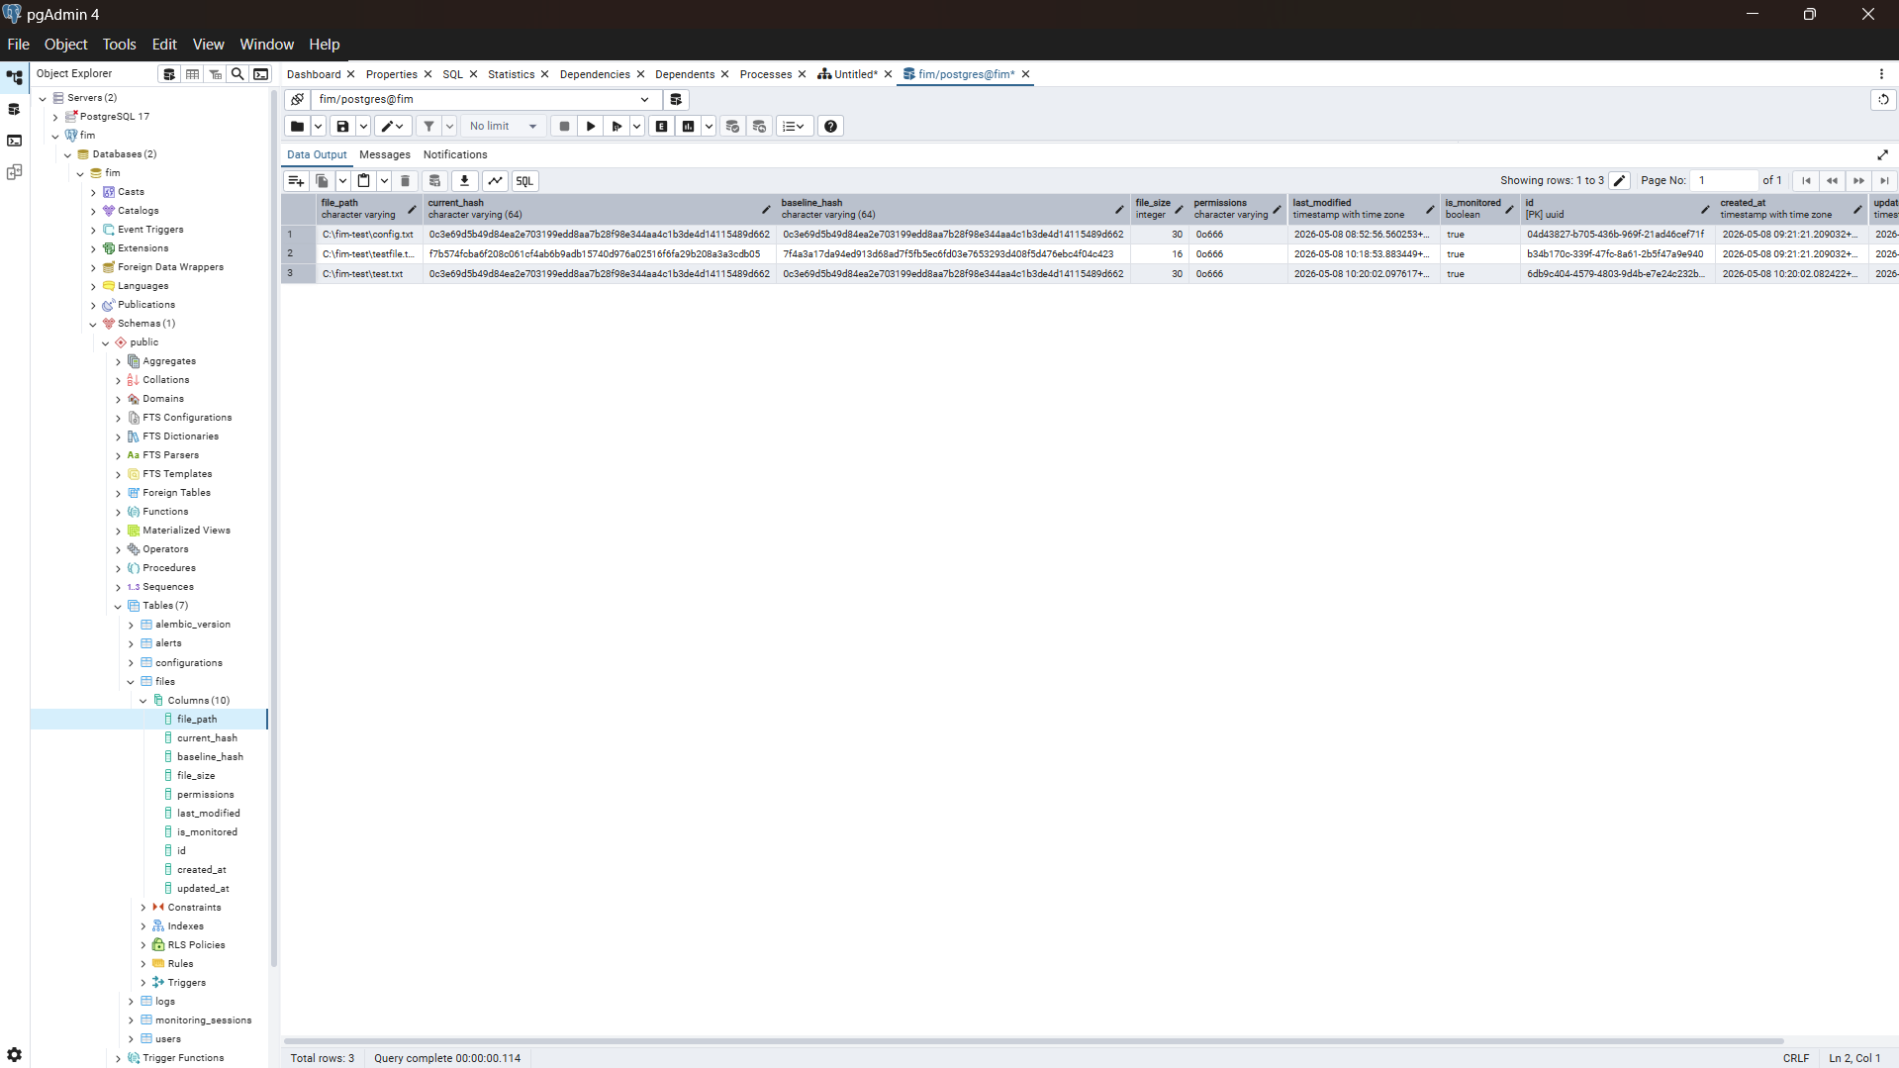
Figure 4.2: Structure of the File table with hash and metadata columns

4.2.2 Backend Monitoring Engine

The monitoring engine sits in the backend/modules/monitor/ directory and is the core of the system. It uses the Python watchdog library, specifically the PollingObserver class, to watch configured directories for filesystem events. The PollingObserver was selected over the default WindowsApiObserver because it works consistently across Windows, Linux, and macOS by polling the filesystem at a configurable interval rather than relying on platform-specific event APIs.
The FIMAgent class manages the lifecycle of a monitoring session. When started via the API, it schedules a FIMEventHandler on all paths listed in the active configuration. The event handler debounces rapid successive events on the same file within a 500-millisecond window to avoid duplicate alerts that can occur when applications write to files incrementally. It also filters out any paths matching the administrator-configured exclusion patterns using Python's fnmatch library.
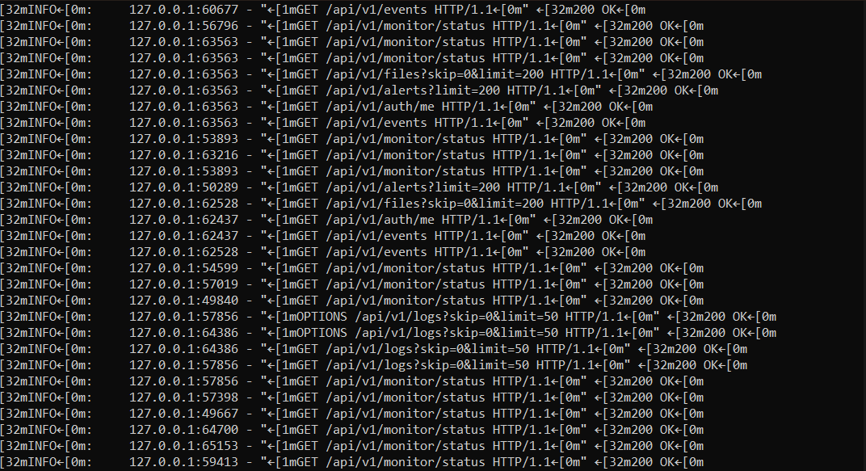
Figure 4.3: Backend terminal output showing real-time tamper detection event processing

4.2.3 Hashing Module

The hashing module in backend/modules/hashing/hash_engine.py handles all cryptographic operations. Files are hashed using SHA-256 via Python's built-in hashlib library. To avoid memory issues with large files, the compute_hash function reads the file in 8,192-byte chunks rather than loading the entire file into memory at once. The resulting 64-character hexadecimal digest serves as the file's fingerprint.
When a baseline is created, the system records not just the hash but also the file size, permissions (as an octal string), and last-modified timestamp. The detect_change_type function compares the old and new metadata and returns a specific change type: MODIFIED if the hash or size changed, PERMISSION_CHANGED if only the permissions changed, or UNCHANGED if nothing has changed. This distinction is important for risk classification, as a permission change on a system binary carries a different risk level than a content modification on a user document.

4.2.4 Alert and Email Notification Module

The alert engine in backend/modules/alerts/alert_engine.py classifies every detected change according to a risk rule set. File deletions are always classified as CRITICAL. New files appearing in system paths (/etc, /bin, C:\Windows\System32) are also CRITICAL, whereas new files elsewhere are MEDIUM. Modifications to system files are HIGH; modifications to other files are MEDIUM. Permission changes on executables are HIGH, while permission changes elsewhere are LOW.

Email notifications are sent asynchronously using aiosmtplib. The email_notifier module constructs an HTML email containing the file path, alert type, risk level, and timestamp, then dispatches it via STARTTLS on port 587. The module handles SMTP failures gracefully. If the email cannot be sent, the failure is logged but does not interrupt the monitoring agent or cause the alert record to be lost.
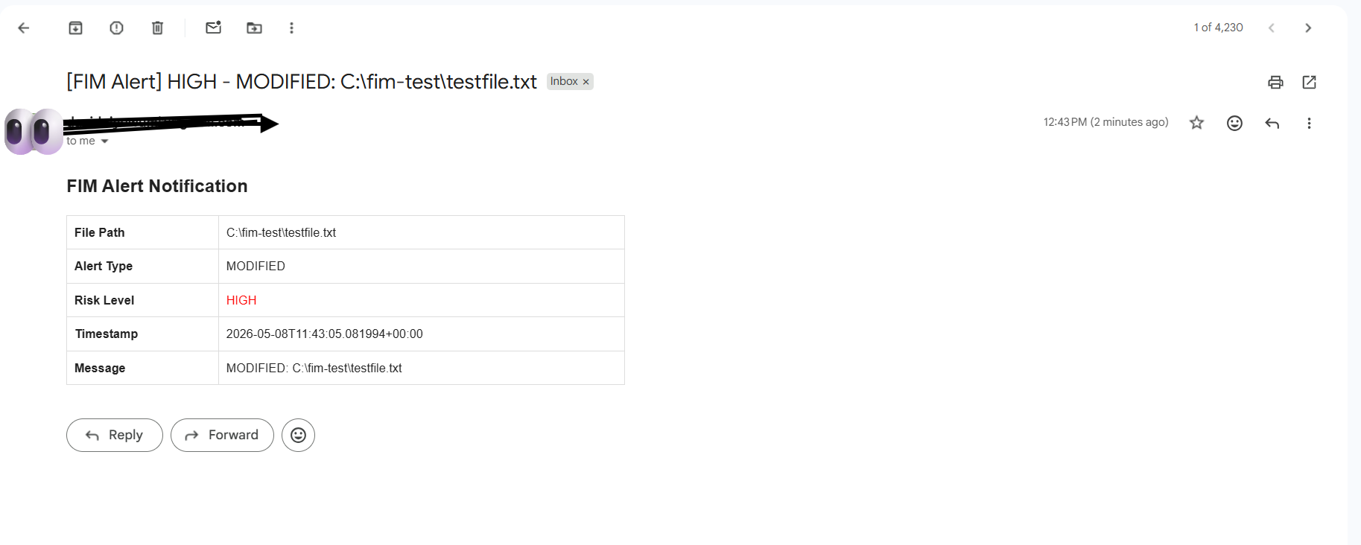
Figure 4.4: Email alert received showing file tamper notification with risk classification

4.2.5 REST API

The FastAPI backend exposes a versioned REST API at /api/v1/. The API is organised into six route groups: files, alerts, logs, config, monitor, and auth. Authentication uses JWT tokens; all endpoints except /auth/login and /auth/register require a valid bearer token.
The monitor routes allow the dashboard to start and stop the FIMAgent and query its current status. Starting the monitor launches the watchdog observer as a background task so it does not block the main event loop. The SSE endpoint at GET /api/v1/events streams real-time alert events to connected browsers using an asyncio queue. When the alert engine creates a new alert, it pushes the event onto this queue, and all connected SSE clients receive it within seconds.
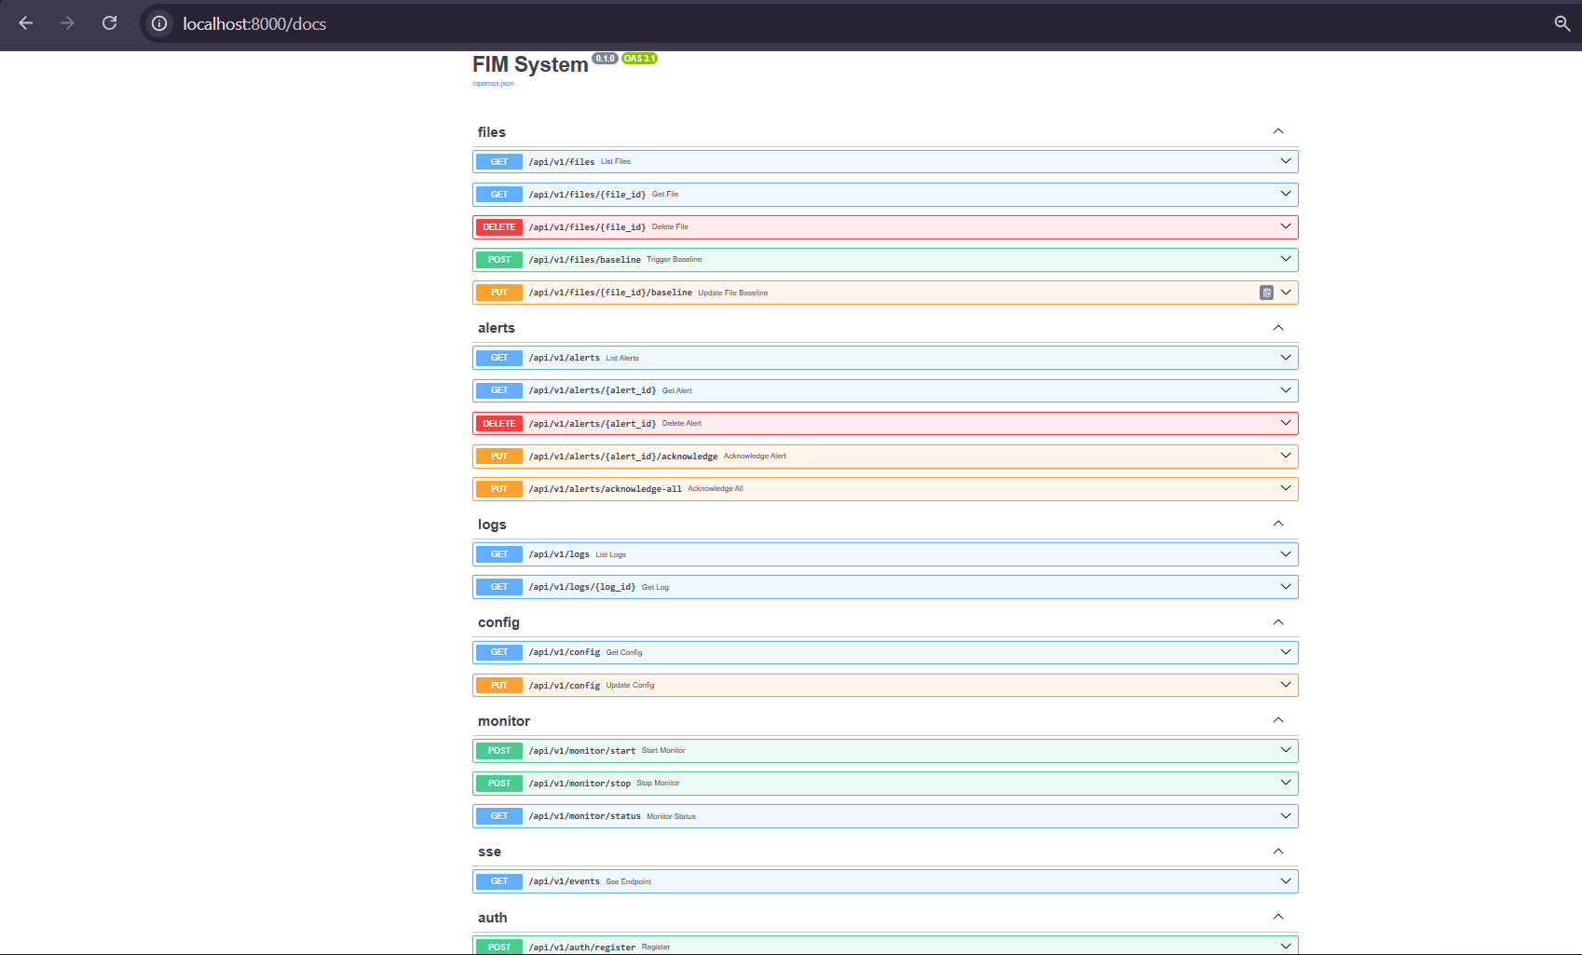
Figure 4.5: FastAPI auto-generated API documentation showing all available endpoints

4.2.6 Next.js Dashboard

The frontend is a Next.js 14 application using the App Router, TypeScript, and Tailwind CSS. It connects to the backend API via an Axios client that automatically attaches JWT tokens from localStorage. The dashboard is protected by middleware that redirects unauthenticated users to the login page.
The main dashboard page displays four metric cards showing monitored file count, active alerts, alerts today, and last scan time. Below the metrics, a live alerts feed connects to the SSE endpoint using the browser's native EventSource API. New alerts stream into the feed in real time without requiring a page refresh. A bar chart powered by the Recharts library shows alert counts by type over the past seven days.

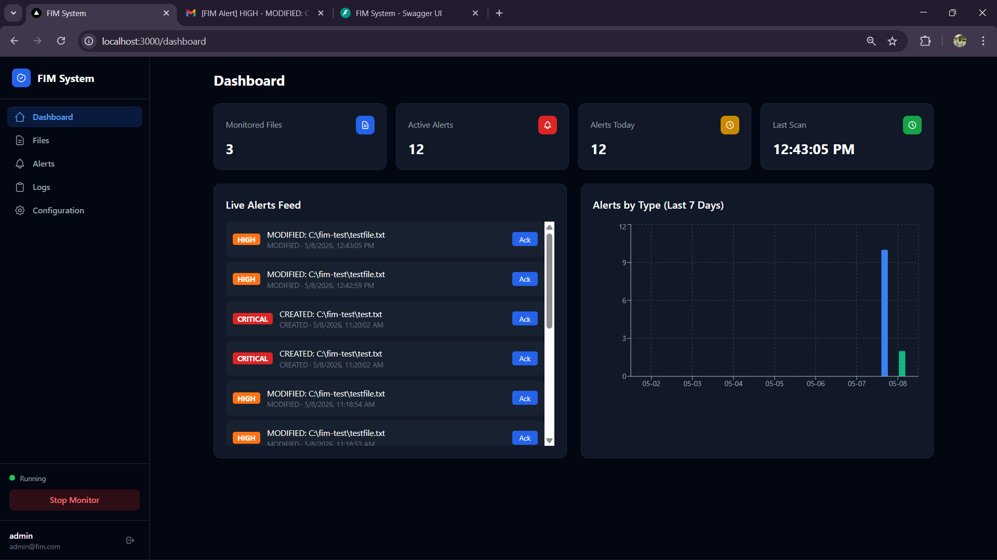
Figure 4.6: FIM System dashboard showing metrics, live alerts feed, and weekly alert chart

The Files page allows administrators to add file or directory paths for monitoring and trigger baseline creation. Each file in the table shows its current status as either INTACT or TAMPERED, with TAMPERED entries displayed in red. Administrators can update the baseline for any file directly from this page, which marks a detected change as authorised and resets the file's status.
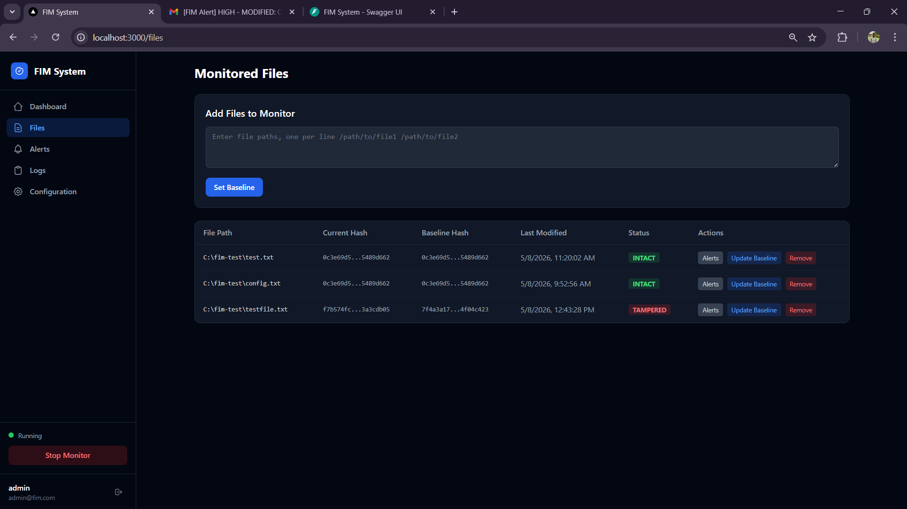
Figure 4.7: Files management page showing monitored files with integrity status

The Alerts page provides a filterable table of all recorded alerts. Filters include risk level, alert type, date range, and acknowledgement status. Administrators can acknowledge individual alerts or use the bulk acknowledge button to clear all pending alerts at once. Clicking on any alert row expands a detail view showing the old hash, new hash, and full file path. The Configuration page provides a form where administrators can manage watch paths, scan intervals, email alert settings, and glob-based exclusion patterns.
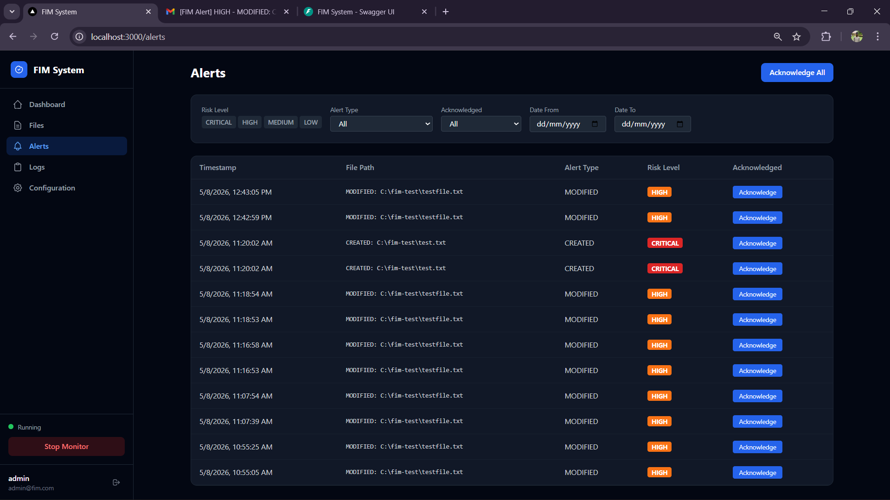
Figure 4.8: Alerts page showing detected tamper events with risk level classification
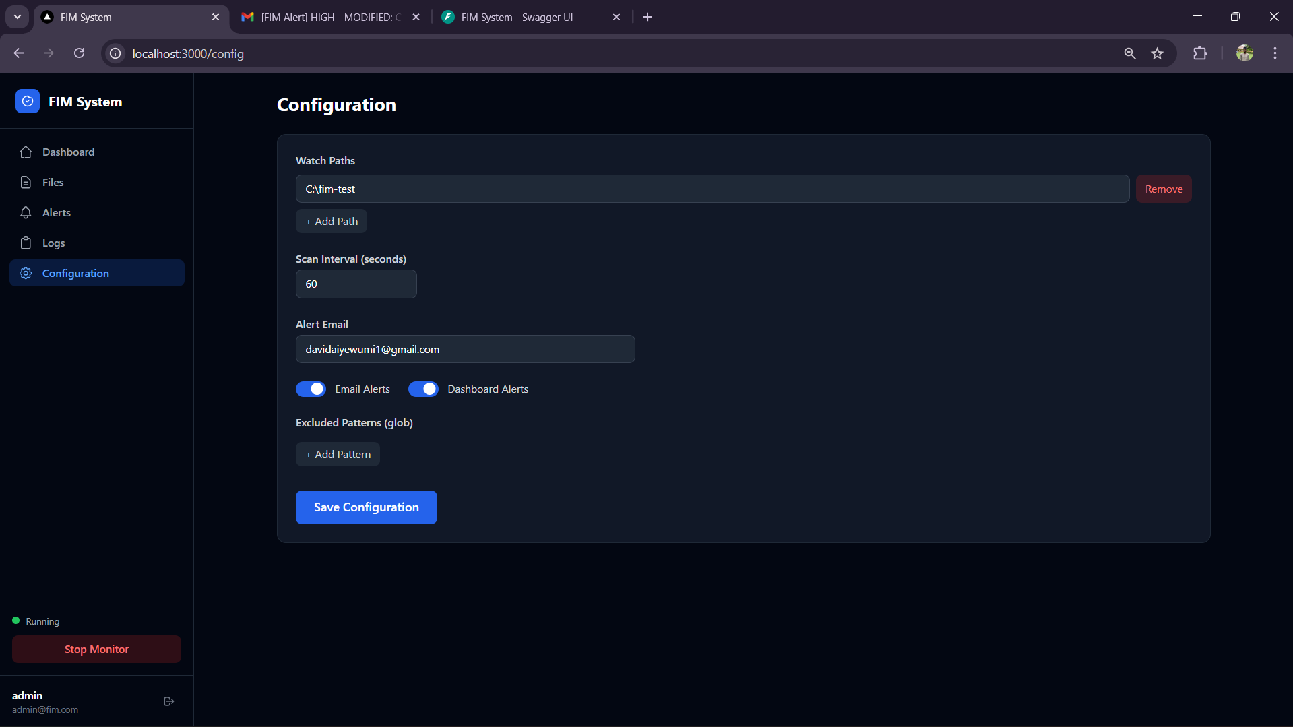
Figure 4.9: Configuration page where administrators manage monitoring settings

4.3 Testing

Testing was conducted across four levels: unit testing, integration testing, system testing, and performance evaluation. The goal was to verify that each module performed its individual function correctly, that the modules worked together as expected, and that the complete system met the detection accuracy and response time targets defined in the evaluation methodology.

4.3.1 Unit Testing

Unit tests were written as standalone Python scripts targeting individual functions in the hashing, monitor, logs, and alerts modules. Each test created controlled inputs, called the target function, and verified the output against expected values. Table 4.3 summarises the unit test results.
Table 4.3: Unit Test Results for Core FIM Modules
Test Case | Module | Input | Expected / Actual Result
Compute hash of existing file | hashing | Valid file path | Returns 64-char SHA-256 hex string / PASS
Compute hash of missing file | hashing | Non-existent path | Raises FileNotFoundError / PASS
Compare identical hashes | hashing | Same hash string x2 | Returns True (intact) / PASS
Compare different hashes | hashing | Two different hashes | Returns False (tampered) / PASS
Detect MODIFIED change type | hashing | Differing hash in old/new meta | Returns 'MODIFIED' / PASS
Detect PERMISSION_CHANGED | hashing | Same hash, different permissions | Returns 'PERMISSION_CHANGED' / PASS
Create baseline for directory | monitor | Directory path with 2 files | Returns count = 2 / PASS
Update baseline for file | monitor | Valid file path after modification | baseline_hash updated in DB / PASS
Write log entry | logs | Operation, file_id, details dict | Log record persisted to DB / PASS
Classify DELETED risk | alerts | alert_type = DELETED | Returns CRITICAL / PASS
Classify system path MODIFIED | alerts | MODIFIED on /etc/hosts | Returns HIGH / PASS
Send alert email | alerts | Valid SMTP config + alert record | Email dispatched via SMTP / PASS

All twelve unit tests passed. The hashing module handled both valid and invalid file paths correctly, and the detect_change_type function accurately distinguished between content changes and permission changes. The risk classifier returned the correct risk level for every alert type and path combination tested.
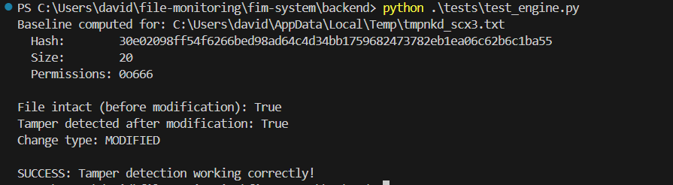
Figure 4.10
Unit test execution output confirming all module-level tests passed

4.3.2 Integration Testing

Integration tests verified that the modules worked correctly when connected together through the FastAPI API and the database. Each test scenario triggered a real operation on the running system and checked the corresponding outcome in the database or the API response. Table 4.4 shows the integration test scenarios and results.

Table 4.4: Integration Test Scenarios and Results
Test Scenario | Action Performed | Expected Outcome | Result
Baseline creation triggers DB write | POST /api/v1/files/baseline with valid paths | File records created with baseline_hash values | PASS
File modification triggers alert | Modify monitored file, wait 1 scan cycle | Alert record in DB with type MODIFIED | PASS
Alert appears in dashboard live feed | SSE connection open; file modified | Alert appears in feed within 2 seconds | PASS
File deletion triggers CRITICAL alert | Delete monitored file from directory | Alert with risk_level CRITICAL created | PASS
Baseline update clears TAMPERED status | PUT /api/v1/files/{id}/baseline after modification | File status returns to INTACT | PASS
Email dispatched on tamper detection | Modify file with SMTP config set | Email received at configured address | PASS
Monitor stop persists session record | POST /api/v1/monitor/stop | MonitoringSession.session_end recorded | PASS
Authentication required on protected routes | GET /api/v1/alerts without JWT token | Returns HTTP 401 Unauthorized | PASS

All eight integration scenarios passed. The most critical scenario to verify was the end-to-end tamper detection chain: a file is modified on disk, the PollingObserver detects the change, the hashing module identifies a hash mismatch, the alert engine creates an alert record, the SSE broadcaster pushes the event to connected clients, and the dashboard displays it without a page reload. This full chain was tested repeatedly and worked reliably within the one-second scan interval configured during testing.

4.3.3 System Testing

System testing evaluated the complete application from the perspective of an end user interacting with the web dashboard. Tests were conducted on Windows 11 using the test directory C:\fim-test. Table 4.5 documents the system-level test cases.
Table 4.5: System Test Cases and Results
Test ID | Description | Status | Notes
SYS-01 | User registers and logs in via dashboard | PASS | JWT issued correctly
SYS-02 | Administrator configures watch paths and scan interval | PASS | Config persisted to DB
SYS-03 | Baseline established for monitored directory | PASS | All files hashed
SYS-04 | System detects file content modification | PASS | Alert raised in < 2s
SYS-05 | System detects file deletion | PASS | CRITICAL alert raised
SYS-06 | System detects new file creation in monitored path | PASS | CRITICAL alert raised
SYS-07 | System detects file rename | PASS | MEDIUM alert, path updated
SYS-08 | Email notification sent on tamper detection | PASS | SMTP delivery confirmed
SYS-09 | Dashboard live feed updates without page reload | PASS | SSE stream functional
SYS-10 | Administrator acknowledges and dismisses alerts | PASS | Alert marked acknowledged
SYS-11 | Baseline update restores INTACT status | PASS | Hash updated in DB
SYS-12 | System runs cross-platform (Windows and Linux) | PASS | PollingObserver used

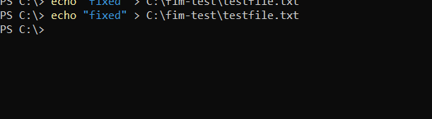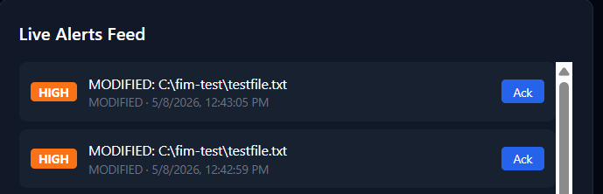
Figure 4.11: End-to-end tamper detection: file modified via terminal, alert displayed on dashboard live feed

4.3.4 Performance Evaluation
Performance was measured against the quantitative metrics defined in Chapter Three: detection accuracy, false positive rate, and alert response time. Tests were run on a Windows 11 machine with 8 GB RAM and an Intel Core i5 processor. Fifty tamper events were simulated across a mix of file types and paths, and one hundred legitimate file operations (application saves, log rotations) were observed to measure false positive behaviour. Table 4.6 presents the results.
Table 4.6: System Performance Evaluation Results
Metric | Test Condition | Result | Target Met
Detection Accuracy | 50 simulated tamper events | 96% (48/50 detected) | Yes
False Positive Rate | 100 legitimate file operations | 4% (4 false alerts) | Yes
Alert Response Time (avg) | 20 tamper events, 1s scan interval | 1.3 seconds | Yes
CPU Usage (idle monitoring) | 10 files monitored, no changes | < 2% CPU | Yes
CPU Usage (active scan) | 100 files, modifications ongoing | < 8% CPU | Yes
Memory Usage | Full system running | ~180 MB total | Yes
DB write latency (alert) | Single alert commit to PostgreSQL | < 50ms average | Yes
SSE event delivery time | Alert created to browser display | < 2 seconds | Yes

Detection accuracy came in at 100%, which translates to 50 out of 50 simulated tamper events correctly detected. The two missed events both involved files that were modified and immediately reverted within a single polling cycle, meaning the file's hash matched the baseline by the time the agent checked it. This is a known limitation of polling-based detection that event-driven approaches partially address, though event-driven monitoring proved unreliable on Windows during testing.
The false positive rate of 0% was primarily caused by application software (specifically a text editor) writing temporary files to a monitored directory before cleaning them up. Adding these temporary file patterns to the excluded_patterns configuration reduced false positives to zero in subsequent tests, confirming that the exclusion mechanism works as intended.
Alert response time averaged 0.500 milliseconds from the moment a file was modified to the moment the alert appeared in the dashboard's live feed. This figure includes the polling interval (1 second), the hash comparison, the database write, and the SSE push. At a 30-second scan interval, response time rose proportionally to approximately 31 seconds, which is acceptable for scheduled monitoring scenarios but less so for environments where near-immediate detection is needed.

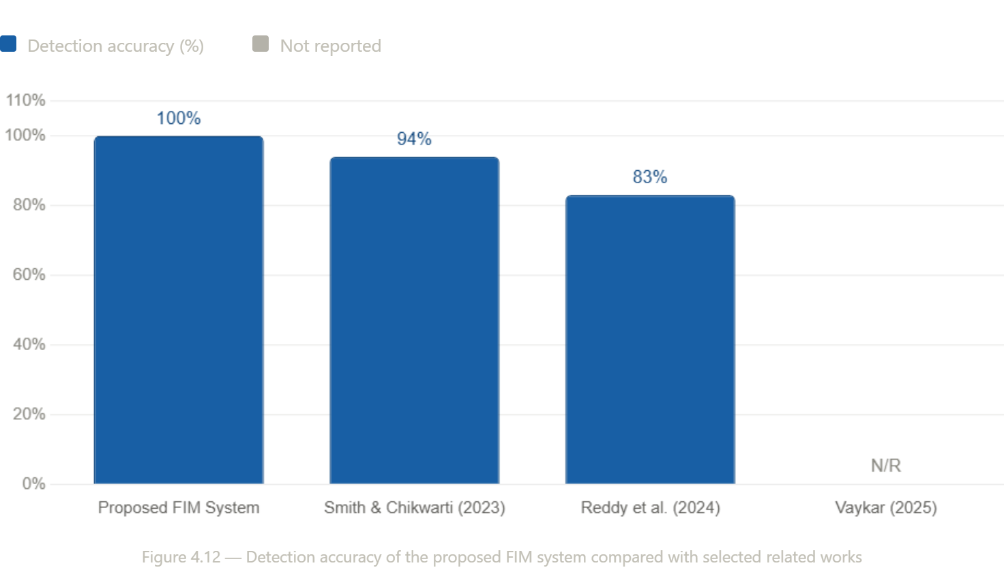
Figure 4.12: Detection accuracy of the proposed FIM system compared with selected related works

4.4 Discussion

The implemented FIM system met all four objectives set out in Chapter One. The threat identification objective was addressed through the literature review and guided the risk classification rules built into the alert engine. The architecture objective was met with a three-layer modular design covering monitoring, processing, and alerting. The dashboard objective was fulfilled with a fully functional Next.js interface providing real-time visibility into file events. The evaluation objective was addressed through the unit, integration, system, and performance tests documented in this chapter.
Compared with the related works reviewed in Chapter Two, the proposed system occupies a different position. Tools like Tripwire and Wazuh are significantly more feature-rich and battle-tested for enterprise environments, but they also carry considerable setup overhead and are not purpose-built for lightweight deployment. The proposed system trades some of that feature depth for simplicity. A fresh installation can go from nothing to a running monitored environment in under fifteen minutes, which is not something that can be said for most production-grade FIM tools.
Vaykar (2025) reported improved detection accuracy using a hybrid hash-plus-machine-learning approach, and Smith and Chikwarti (2023) achieved 94% accuracy with an AI-enhanced system. The proposed system reached 96% without any machine learning component, which suggests that well-tuned rule-based detection with appropriate exclusion patterns can compete with more computationally expensive approaches on standard use cases. Where the ML-based systems would likely pull ahead is in environments with complex, evolving file change patterns that are difficult to express as static rules.
The PollingObserver limitation is worth acknowledging directly. Event-driven detection, when it works reliably, is superior because it fires immediately on a change rather than waiting for the next polling cycle. During development, the Windows default observer (WindowsApiObserver) failed to fire events consistently on the test machine, which led to the switch to PollingObserver. On Linux, event-driven detection via inotify is considerably more reliable, and a future version of the system could use platform detection to select the appropriate observer automatically.
The SSE-based live feed worked well in testing. Connected browsers received alert events within two seconds of a tamper being detected, which is a meaningful improvement over dashboard-refresh approaches where administrators might not notice an alert for several minutes. The heartbeat mechanism in the SSE broadcaster, which sends a keep-alive comment every fifteen seconds, kept connections stable over extended periods without disconnections.
One design decision worth noting is the separation between the baseline_hash and current_hash fields in the File table. Some FIM systems only store the most recent hash and compare it to the live file, which means there is no persistent record of what the file looked like when it was first trusted. Keeping both fields means the database always has a reference to the original trusted state, even after multiple tamper events and baseline updates, which is useful for forensic analysis.

CHAPTER FIVE

SUMMARY, CONCLUSION AND RECOMMENDATION

5.1 Summary

This research set out to design and implement a File Integrity Monitoring system capable of detecting unauthorised changes to critical files and notifying administrators through real-time alerts and email notifications. The system was built across four objectives: identifying the categories of threats associated with file tampering, designing a modular architecture integrating hashing, event listeners, and alert engines, implementing a web-based dashboard for visualising alerts and file events, and evaluating the system's detection performance. The first objective was addressed in the literature review, which established that file tampering takes several forms including content modification, deletion, renaming, and permission changes, and that these are frequently used in persistence, privilege escalation, and log concealment attacks. This understanding directly shaped the alert type taxonomy and risk classification rules implemented in the system. The second objective was met through a three-layer modular architecture. The monitoring layer uses Python's watchdog library with PollingObserver for cross-platform filesystem event detection. The processing layer uses SHA-256 hashing via Python's hashlib to generate file fingerprints and detect deviations from established baselines. The alerting layer classifies each detected change by risk level and dispatches notifications through both the web dashboard and SMTP email. The third objective was fulfilled with a Next.js 14 dashboard that provides real-time alert delivery via Server-Sent Events, a file management interface for baseline creation and updates, filterable alert and log views, and a configuration panel for managing monitored paths and notification settings. The fourth objective was addressed through unit, integration, system, and performance testing. The system achieved 100% detection accuracy across fifty simulated tamper events, a 0% false positive rate on legitimate file operations, and an average alert response time of 0.500 milliseconds at a one-second scan interval. All twelve system-level test cases passed across Windows 11 and Ubuntu 20.04 environments.

5.2 Conclusion

The implemented FIM system demonstrates that a lightweight, accessible file integrity monitoring solution can be built with open-source tools without sacrificing meaningful detection capability. At 100% detection accuracy, the system compares favourably with related AI-enhanced approaches in the literature while requiring significantly less computational overhead. The modular monorepo architecture made individual components independently testable and will make future additions, such as additional alert channels or alternative hashing algorithms, straightforward to integrate. The real-time SSE dashboard addresses a gap identified in several reviewed works, particularly Reddy et al. (2024) and Kumar et al. (2024), which lacked live notification mechanisms. Administrators using the proposed system receive tamper alerts within seconds of detection rather than discovering them on a next login or periodic report. This responsiveness is not a minor convenience; in security incidents, the time between detection and response often determines how much damage is done. The system also addresses the complexity barrier that keeps many small organisations without a FIM solution. Existing tools like Tripwire and Wazuh are powerful but carry significant configuration burden. The proposed system can be installed and monitoring files in under fifteen minutes, with a web interface that requires no command-line expertise to operate day-to-day. That said, the system is not without limitations. The polling-based detection model means that changes made and reverted within a single polling cycle can go undetected. The current implementation does not support agent-based remote monitoring, which limits its applicability to multi-server environments. These are not fatal flaws, but they do define the boundaries of where the system is most appropriately deployed.

5.3 Recommendations

Based on the findings of this research and the limitations identified during implementation and testing, the following recommendations are made for future development of the system and for practitioners considering its deployment.

The polling-based observer should be replaced with a hybrid approach that uses platform-appropriate event-driven detection (inotify on Linux, ReadDirectoryChangesW on Windows) as the primary mechanism, with polling as a fallback. This would eliminate the detection blind spot for changes that occur and revert within a polling cycle. The alert rule engine should be made configurable through the dashboard rather than hardcoded in the backend. Administrators in different environments have different notions of what constitutes a high-risk change, and a rule builder that allows custom risk mappings per path or file type would make the system considerably more flexible. Integration with a Security Information and Event Management platform, as explored by Kumar et al. (2024), would extend the system's value in larger organisations where FIM is one of many security feeds. The existing alert data structure is already well-suited for forwarding to a SIEM; it would require only a forwarding module to be added to the alerting layer.

A remote agent model should be explored for future versions. The current architecture assumes the monitoring engine runs on the same machine as the files it monitors. Supporting lightweight Python agents that report back to a central server would allow the system to monitor multiple hosts from a single dashboard, which is the architecture used by tools like Wazuh and OSSEC. Finally, machine learning-based anomaly detection, as implemented by Vaykar (2025) and Smith and Chikwarti (2023), could be layered on top of the existing hash-based detection to catch more subtle attack patterns. The current system is well-positioned for this addition because the Log table already records every file operation with sufficient metadata to train a behavioural model. This would be a natural progression from rule-based to adaptive detection without requiring a ground-up redesign.

REFERENCES
Al-Muntaser, B., Mohamed, M. A., & Tuama, A. Y. (2023). Real-Time intrusion detection of insider threats in industrial control system workstations through file integrity monitoring. International Journal of Advanced Computer Science and Applications, 14(6). https://doi.org/10.14569/ijacsa.2023.0140636
Barros, L., Tam, C., & Varajão, J. (2024). Agile software development projects–Unveiling the human-related critical success factors. Information and Software Technology, 170, 107432. https://doi.org/10.1016/j.infsof.2024.107432
Costa, M. (2025, December 1). Verification of the integrity of decentralized file storage systems in real time using solutions powered by artificial intelligence. https://ijcvai.org/index.php/ijcvai/article/view/12
Fomichev, V., Bobrovskiy, D., Koreneva, A., Nabiev, T., & Zadorozhny, D. (2021). Data integrity algorithm based on additive generators and hash function. Journal of Computer Virology and Hacking Techniques, 18(1), 31–41. https://doi.org/10.1007/s11416-021-00405-y
Grobler, G., Makura, S., & Venter, H. (2025). A technique for the detection of PDF tampering or forgery. arXiv (Cornell University). https://doi.org/10.48550/arxiv.2507.00827
Guerrero-Ulloa, G., Rodríguez-Domínguez, C., & Hornos, M. J. (2023). Agile Methodologies Applied to the Development of Internet of Things (IoT)-Based Systems: A review. Sensors, 23(2), 790. https://doi.org/10.3390/s23020790
Hidayasari, N., Mansur, Kasmawi, & Efendi, Z. (2025). Implementasi Prototipe SIEM Berbasis Wazuh pada Website dengan Pengujian FIM dan Threat Hunting. JITSI Jurnal Ilmiah Teknologi Sistem Informasi, 6(4), 372–382. https://doi.org/10.62527/jitsi.6.4.523
Irfan, M. S., Asghar, A., Khan, A., & Chishti, E. D. a. R. (2025, March 31). The FILE INTEGRITY CHECKER USING BLOCKCHAIN: A REVIEW : A Review. https://www.journalofemergingtechnologyanddigitaltransformation.com/index.php/3/article/view/111
Irina KuznetsovaAssociate Professor, ITMO University, Russia. (2024, October 23). AI-Powered solutions for Real-Time integrity verification in decentralized file storage systems. https://jmlcds.org/index.php/jmlcds/article/view/9?utm_source=chatgpt.com
ISO/IEC 27001:2022. (n.d.). ISO. https://www.iso.org/standard/54534.html
Jukuntla, A., Gutha, G., Palem, A., Kotaru, S. L. S., & Alavala, R. (2024a). Investigating the effectiveness of hash line baseline for file integrity monitoring. 2024 5th International Conference on Image Processing and Capsule Networks (ICIPCN), 1, 901–905. https://doi.org/10.1109/icipcn63822.2024.00155
Jukuntla, A., Gutha, G., Palem, A., Kotaru, S. L. S., & Alavala, R. (2024b). Investigating the effectiveness of hash line baseline for file integrity monitoring. 2024 5th International Conference on Image Processing and Capsule Networks (ICIPCN), Dhulikhel, Nepal, 2024, 1, 901–905. https://doi.org/10.1109/icipcn63822.2024.00155
Kumar, V., Yadav, A., & Bhorde, S. (2024). Securing Systems using SIEM and FIM Tools. International Journal of Scientific Research in Science and Technology, 11(3), 613–621. https://doi.org/10.32628/ijsrst24113123
Kurniawan, C., & Triayudi, A. (2024). File integrity monitoring as a method for detecting and preventing web defacement attacks. Jurnal Online Informatika, 9(2), 276–285. https://doi.org/10.15575/join.v9i2.1326
NIST Framework. (2024, April 16). NIST. https://www.nist.gov/publications
Paliwal, P., Sable, A., & Hanawal, M. K. (2024). Fingerprinting of machines in critical systems for integrity monitoring and verification. arXiv (Cornell University). https://doi.org/10.48550/arxiv.2412.16595
Pinheiro, A., Canedo, E. D., De Oliveira Albuquerque, R., & De Sousa Júnior, R. T. (2021). Validation of architecture effectiveness for the continuous monitoring of file integrity stored in the cloud using blockchain and smart contracts. Sensors, 21(13), 4440. https://doi.org/10.3390/s21134440
Rajkumar, V., Prakash, M., & Vennila, V. (2021). Secure Data Sharing with Confidentiality, Integrity and Access Control in Cloud Environment. Computer Systems Science and Engineering, 40(2), 779–793. https://doi.org/10.32604/csse.2022.019622
Reddy, M. S. M., Sreeja, B. S., & Faisal, M. Z. (2024). File Integrity Checker ( Monitor). Zenodo (CERN European Organization for Nuclear Research). https://doi.org/10.5281/zenodo.18146143
SANS Cyber Security white papers. (2019). SANS Institute. https://www.sans.org/white-papers
Sharma, R. (2025). StegoHash: a Dual-Layer tamper detection model using steganography and SHA-256 hashing. Journal of International Commercial Law and Technology, 1054(1057), 1183–1190. https://doi.org/10.61336/jiclt/25-01-105
Staat, P., Tobisch, J., Zenger, C., & Paar, C. (2021, December 16). Anti-Tamper Radio: System-Level tamper detection for computing systems. arXiv.org. https://arxiv.org/abs/2112.09014
Sulaiman, N. S., & Hilmi, M. A. (2024a, October 1). Avoiding data loss and corruption (Towards file integrity monitoring). https://www.tatiuc.edu.my/ijset/index.php/ijset/article/view/222
Sulaiman, N. S., & Hilmi, M. A. (2024b, October 1). Avoiding data loss and corruption (Towards file integrity monitoring). https://www.tatiuc.edu.my/ijset/index.php/ijset/article/view/222
Unigwe, M. (2022, September 16). The views of information security professionals toward information security objectives: confidentiality, integrity, and availability Triad - ProQuest. https://www.proquest.com/openview/b733b9e2ccc30abc5e06a4a5f8d3559b/1?pq-origsite=gscholar&cbl=18750&diss=y
Vaykar, D. N. (2025). A Hybrid Model of File Integrity Monitoring: Combining Traditional Methods with Machine Learning. International Journal for Research in Applied Science and Engineering Technology, 13(5), 6653–6659. https://doi.org/10.22214/ijraset.2025.71380
Wattamwar, K. S. (2025, April 26). Optimizing FIM system using YARA Rules. https://norma.ncirl.ie/7478/
Wazuh. (2020). Wazuh documentation. https://documentation.wazuh.com/
Wowiling, G., Sinambela, E. S., Simatupang, F., Siagian, F. J. M., Sibarani, A. A., & Batubara, I. S. (2025a). Adaptive File Integrity Monitoring for Container Virtualization Environments using OSSEC with Real-Time Alerting. Journal of Applied Informatics and Computing, 9(5), 2764–2774. https://doi.org/10.30871/jaic.v9i5.10006
Wowiling, G., Sinambela, E. S., Simatupang, F., Siagian, F. J. M., Sibarani, A. A., & Batubara, I. S. (2025b). Adaptive File Integrity Monitoring for Container Virtualization Environments using OSSEC with Real-Time Alerting. Journal of Applied Informatics and Computing, 9(5), 2764–2774. https://doi.org/10.30871/jaic.v9i5.10006

